* **Introduction**

Platinum is a web application to manage credit card application process, personal loan process, expenses management, attendance records and payroll management etc

* **Login**

Platinum allows users to log in using your username and password to you by the admin.

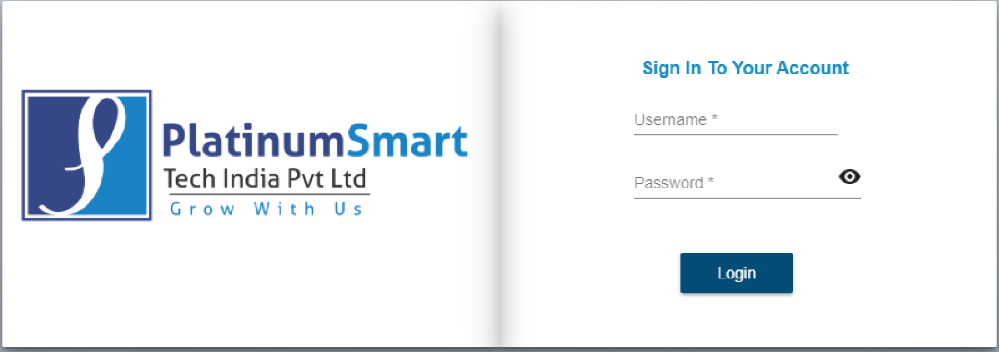

Fig. Login Page

* **Access Control**
* Login with valid .credentials
* Click on access control module.
* Click on search field.
* Search username which admin wants to give access of particular module to that user.
* Click on edit operation.

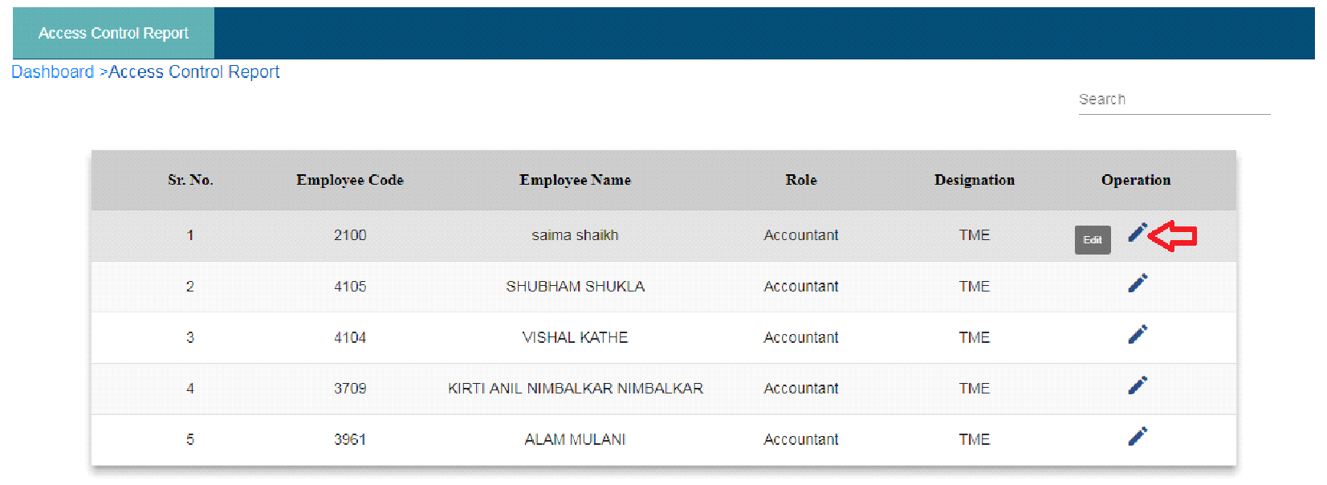 Fig. Access Control

* Click on the checkbox of particular module which admin wants to give access to the user.
* Click on the update button.
* Click on cancel button if user wants to navigate back to the access control page.

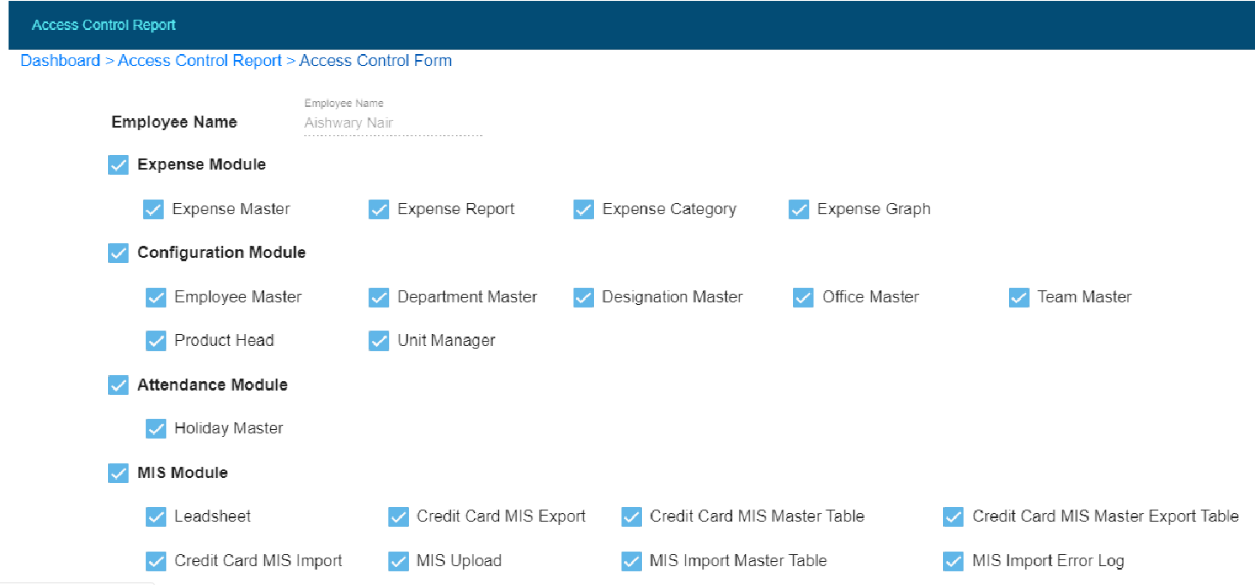

Fig. Access Control Update Button

* **Configuration**
* Click on configuration module.

**a) Department Master**

* Click on department master.
* Click on add department button.
* Enter department name.
* Click on create button.

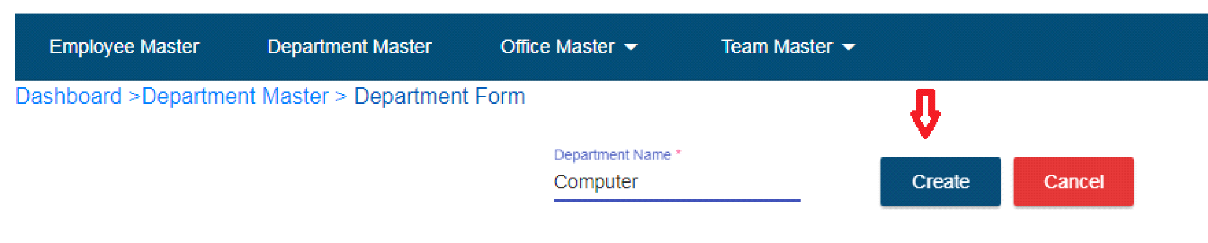

Fig. Department Master

* Record will display in department master table.
* Search field is available if user wants to search department name.
* If user wants to update particular record then click on edit operation.

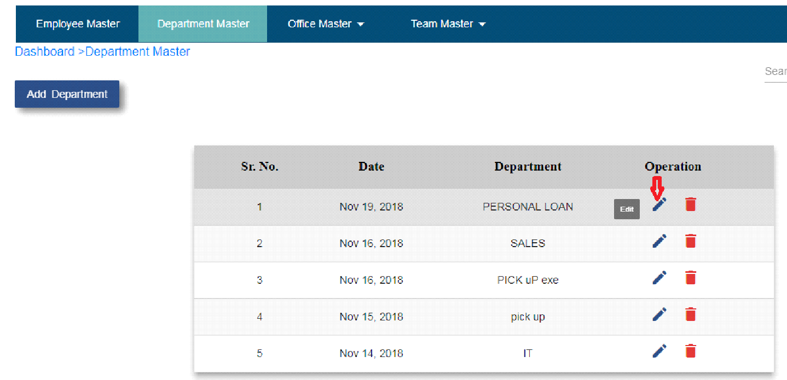

Fig. Department master edit button

* Enter department name.
* Click on the update button.
* If user keep department name as it is and click on the update button then “Department name already exist” pop up display.
* If user doesn’t want to update department name then click on cancel button.
* Click on the delete operation to delete particular record.

**b) Office Master**

* Click on office master

**1. Add Office**

* Click on add office sub tab.
* Enter city name.
* Enter address.
* Click on create button.
* Record will show in offices table.

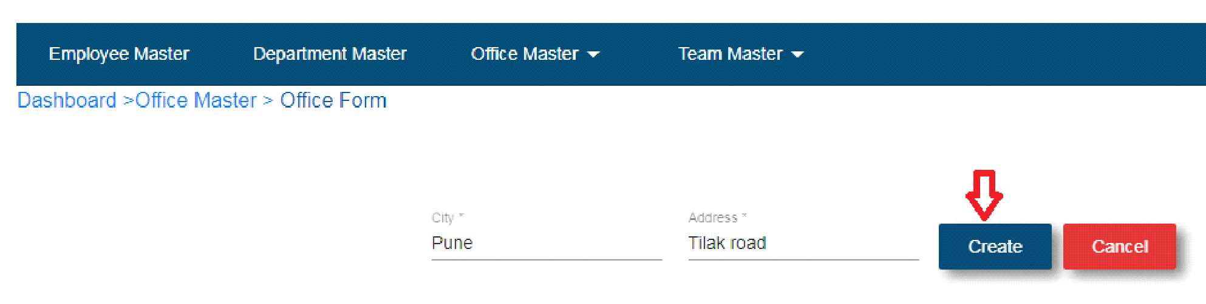 Fig. Add office

**2. Offices**

* Click on offices sub tab.
* Click on edit operation.
* If user wants to update city name and address then enter city and address.
* Click on the update button.

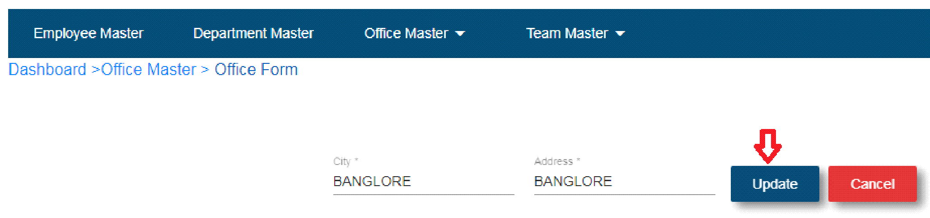 Fig. Offices Update Button

* Click on the delete button to delete particular record.
* If users want to search any record then click on search field.

**2. Add Sub Office**

* Click on add sub office.
* Select city.
* Enter sub office name.
* Click on the add button.
* Record will show in sub office table.

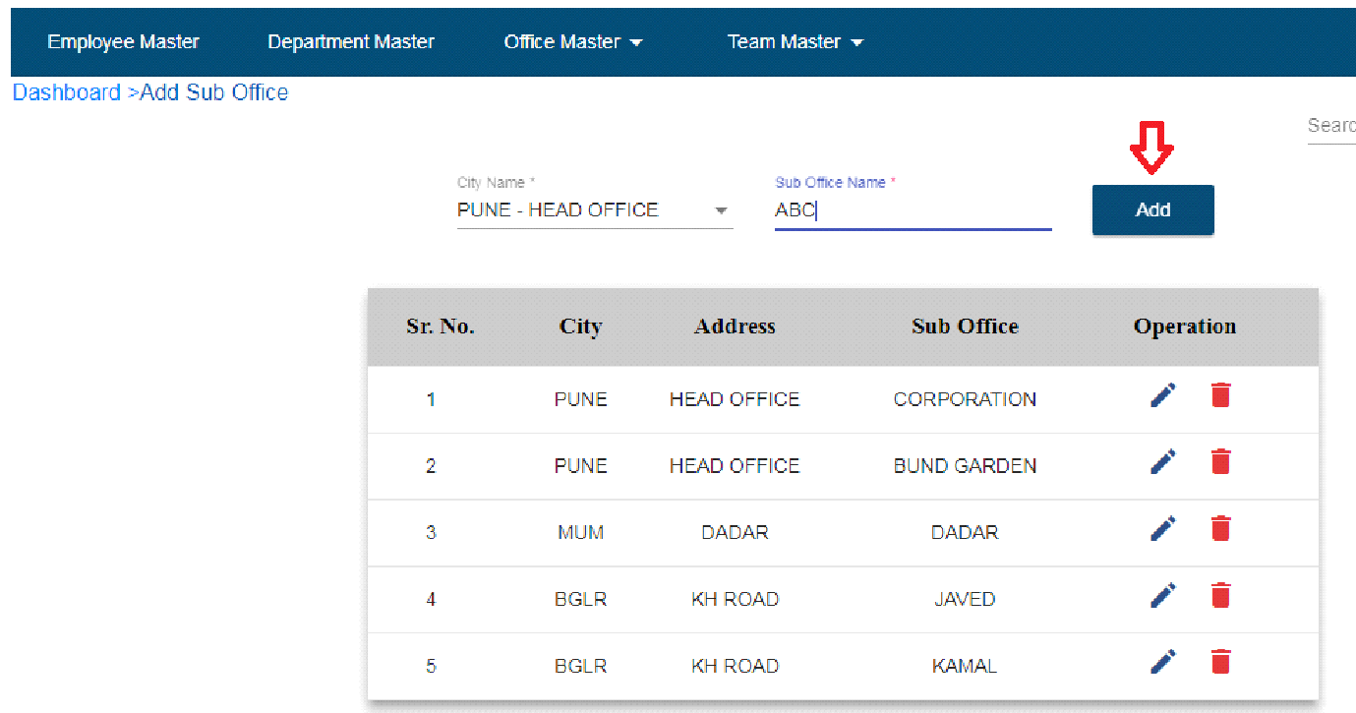

Fig. Add sub Office

* Click on edit operation.
* If user wants to update sub office name then enter sub office name.
* Click on update button.
* If user doesn’t want to update sub office name then click on cancel button.
* Click on delete button to delete particular record.
* Search field is available to search the record.

**c) Employee Master**

* Click on employee master.
* Click on add employee button.
* Enter employee code – User should be able to enter characters, integers, special symbols.
* Enter email id – User should be able to enter email id in “[abc@gmail.com](mailto:abc@gmail.com)”
* Enter first name.
* Enter last name.
* Select role.
* Select designation.
* Select office.
* Select sub office.
* Select In time – HH:MM:AM/PM
* Select Out time – HH:MM:AM/PM
* Select department
* Enter password
* Click on password visibility – User is able to see entered password
* Choose date of joining
* Select process
* Select salary type
* Enter salary
* Bank Name
* Account No
* IFSC Code
* CITI DSR CODE
* ICICI DSR CODE
* HDFC DSR Code
* YES DSR Code
* SCB DSR Code
* RBL DSR Code
* INDUSIND DSR Code
* Hide Salary
* PF and ESIC
* Click on create button

**Note: * indicates all fields are mandatory**

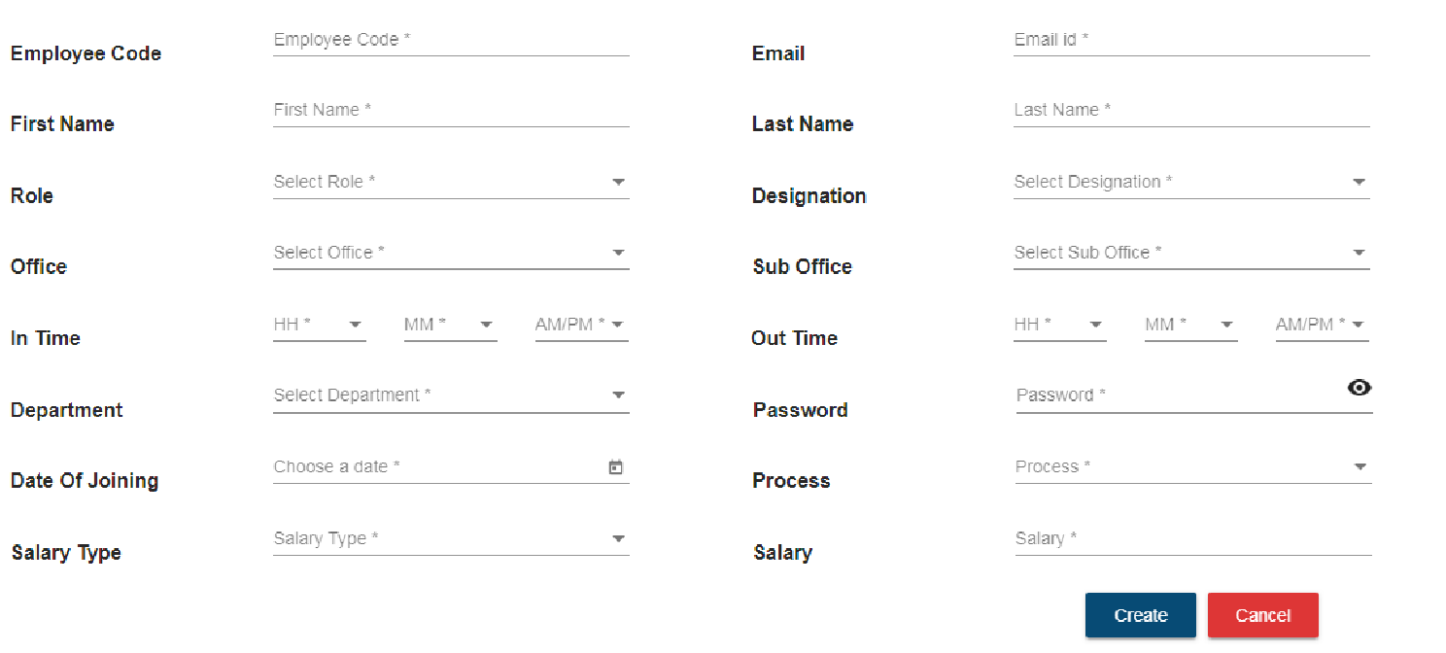

Fig. Employee Master Form

* After click on create button employee record will be show in the employee master table.
* Click on edit button if user wants to update employee record.
* Click on delete button to delete record.
* **Incentives**
* **FOS Freelancer**
* Click on incentive operation with FOS Freelancer designation.
* Go to Bank Card Amount section
* Select bank name and card type.
* Enter amount.
* Click on create button.
* Super admin need to approve that bank card and amount details by clicking on approved button.

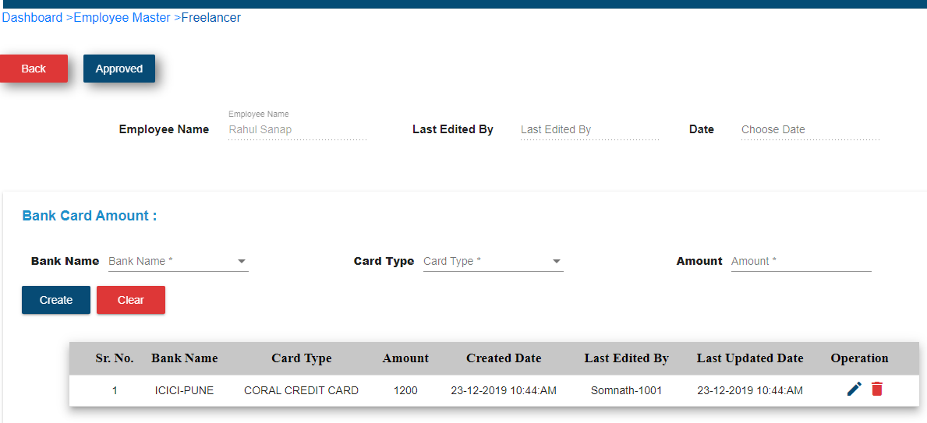

Fig.Fos Freelancer incentive of credit card

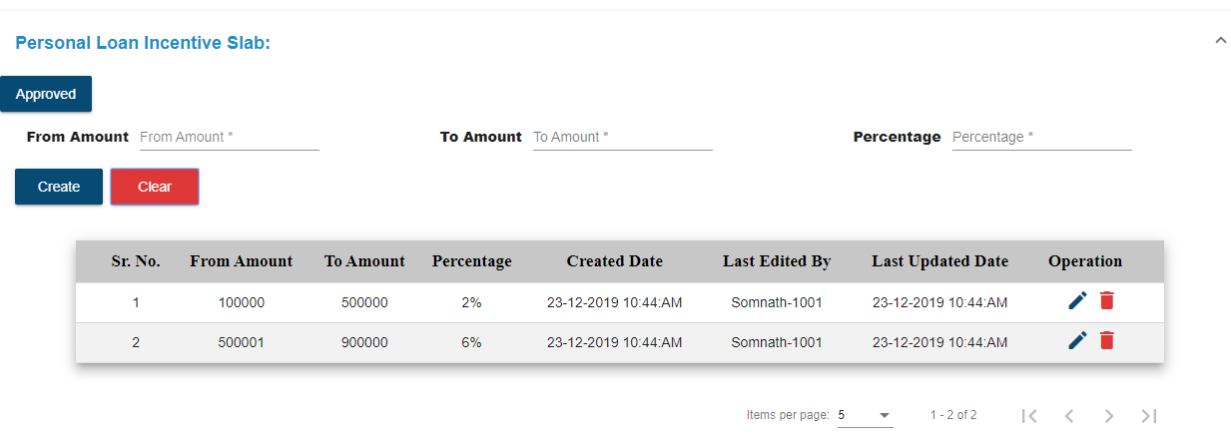

Fig. FOS Freelancer Personal loan Incentive

* **FOS Target**
* Click on incentive operation with FOS Target designation.
* Go to Incentive Slab section
* Enter point and rate .
* Click on create button.
* Super admin need to approve that point and rate details by clicking on approved button.

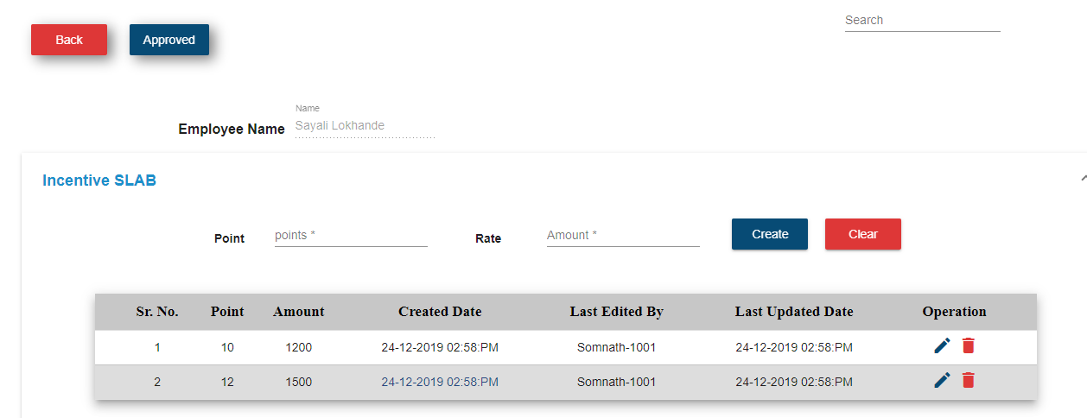

**Fig.Incentive slab off credit card**

Go to personal loan incentive section

* Enter From Amount and To amount fields
* Click on create button.
* Super admin need to approve that From and To Amount details by clicking on approved button.

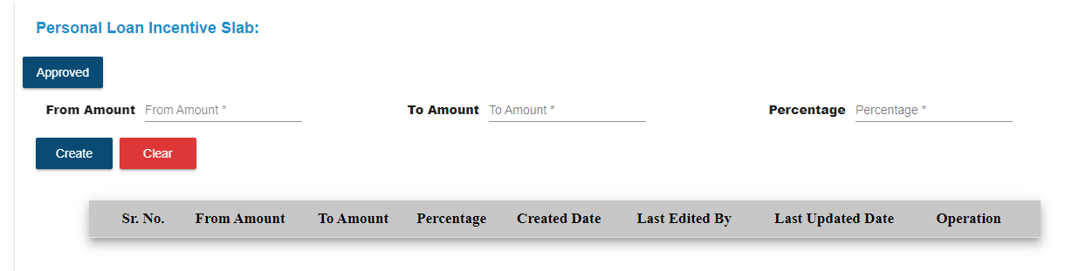

**Fig.Incentive slab of personal loan**

* **Pick up executive incentive**
* Click on incentive operation of pick up executive designation.
* Enter Collection for all banks.
* Enter PL Commission.
* Click on the update button
* Click on approved button to approve the record.

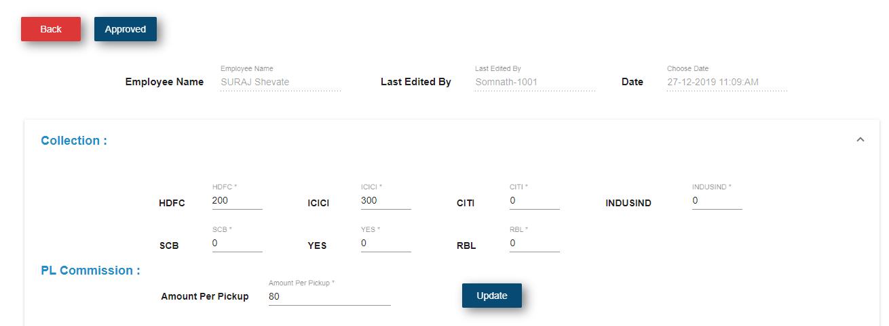

Fig. Pick Up Executive

* Enter amount of selected bank name and card type.
* Approve bank card details by super admin.

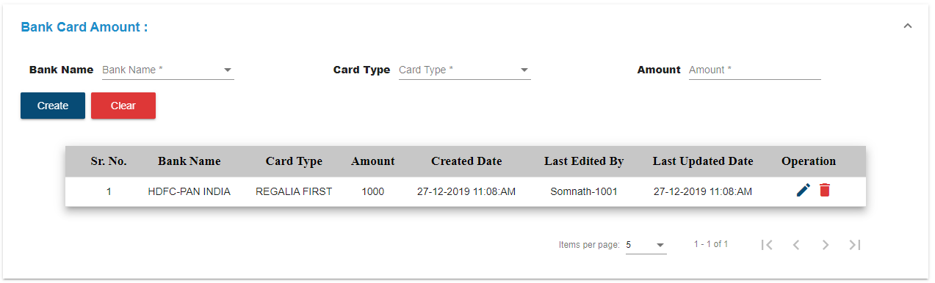

* Enter from amount,to amount and percentage for the personal loan slab.
* Approve incentive slab by superadmin.

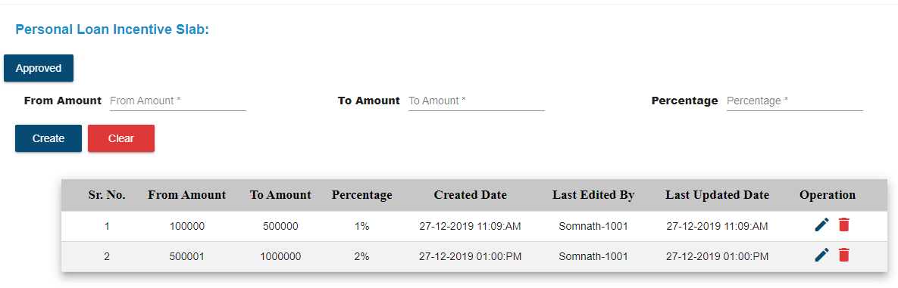

* **TME**
* **Process – Multi Salary Type – Target**
* Click on incentive operation of TME designation with process multi and salary type target.
* Enter points.
* Enter amount.
* Click on create button.
* User can edit point and amount by click on edit operation.

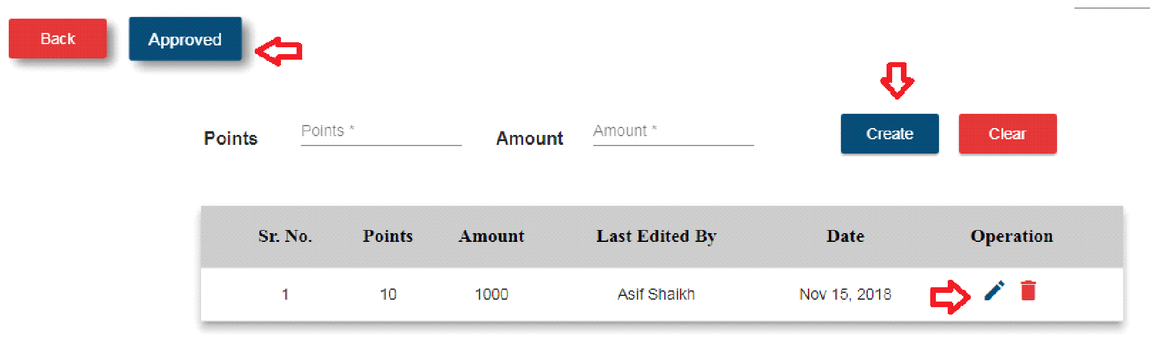

Fig. TME Multi Target

* Once points and amount update and approved that incentive then user get incentive according to TME excel sheet format.
* **TME Cross Sell** - Enter Disbursed percentage for cross sell calculation and approved by super admin

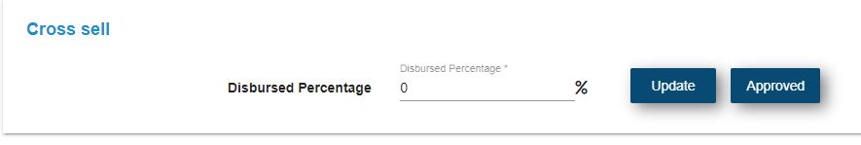

* **Process – Citi Salary Type – Target**
* Click on incentive operation of TME designation with process citi and salary type target.
* Enter booking.
* Enter Amount.
* Click on create button.
* Click on approved button.
* After click on approved button incentive will be approved.
* If user complete the target then incentive will calculate as per TME excel sheet format.

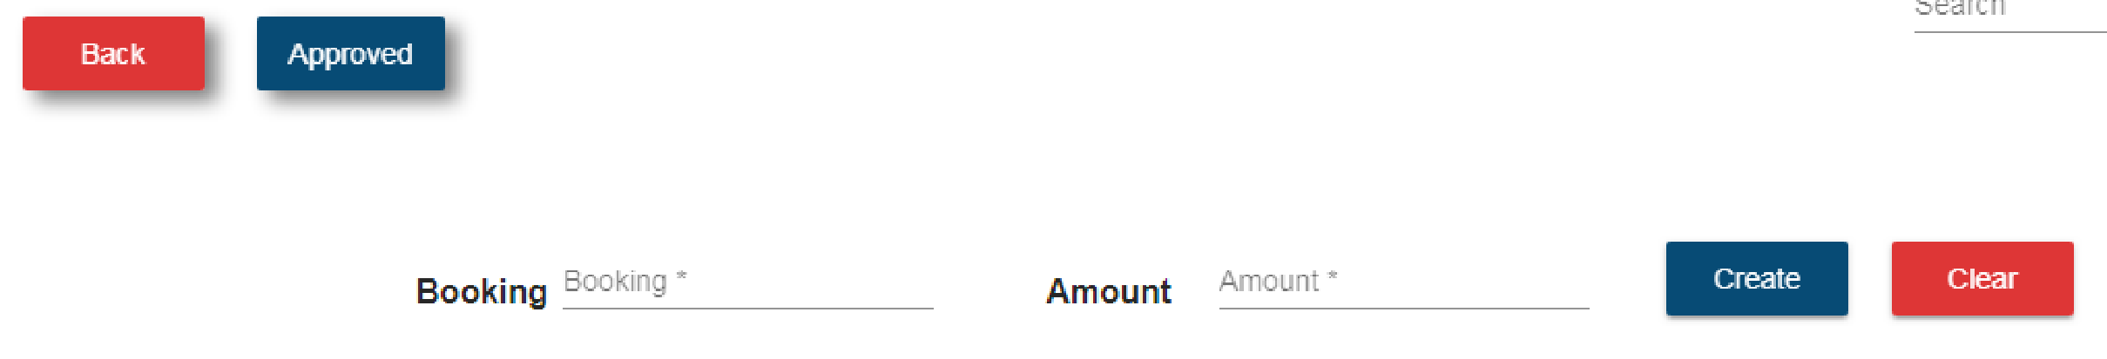

Fig. TME Citi Target

* **Process – SCB Salary Type – Target**
* Click on incentive operation of TME designation with process scb and salary type target.
* Enter booking.
* Enter amount.
* Click on create button.
* Click on approved button.
* After click on approved button, incentive will be calculated.
* When user completes the target then user get incentive as per SCB TME excel sheet format.

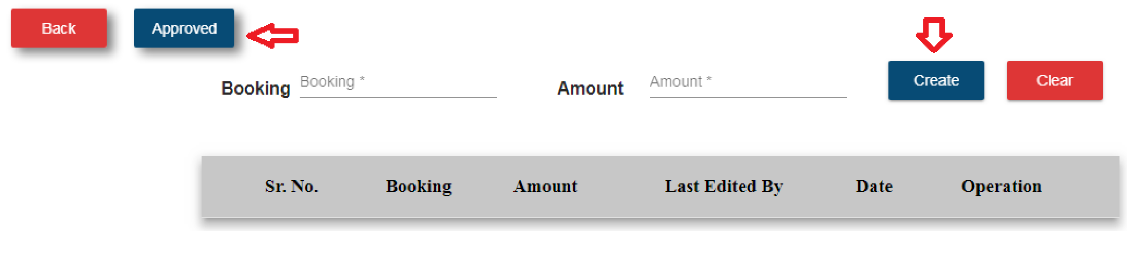

Fig. TME SCB Target

**Personal loan incentive slab** -

* Enter From amount and To Amount fields
* Enter percentage and click on create button.
* Superadmin can approve details by clicking on Approved button

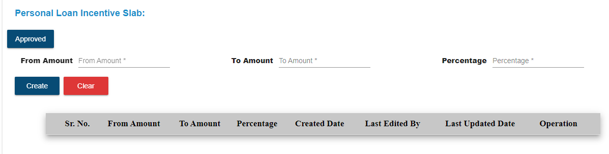

* **Team Manager incentive -**

**1) Process – Multi Salary Type – Target**

* Click on incentive operation of designation team manager with process multi and salary type target.
* Enter each bank amount.
* Click on the update button.
* Click on approved button.

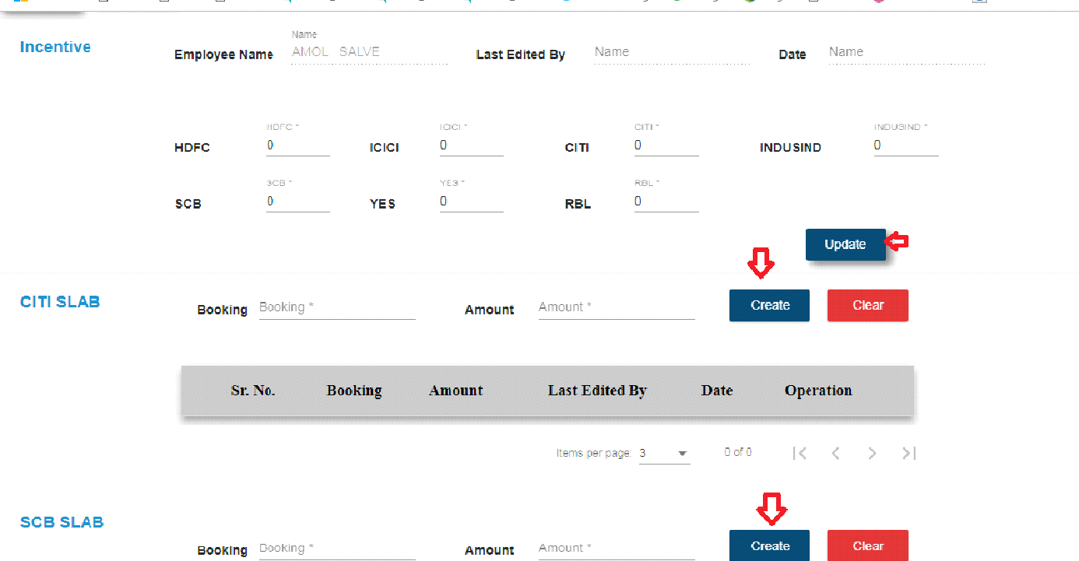

Fig. Team Manager Multi Target

**2) Process – Citi Salary Type – Target**

* Click on incentive operation of designation team manager with process citi and salary type target.
* Enter booking.
* Enter amount.
* Click on create button.
* Click on approved button.

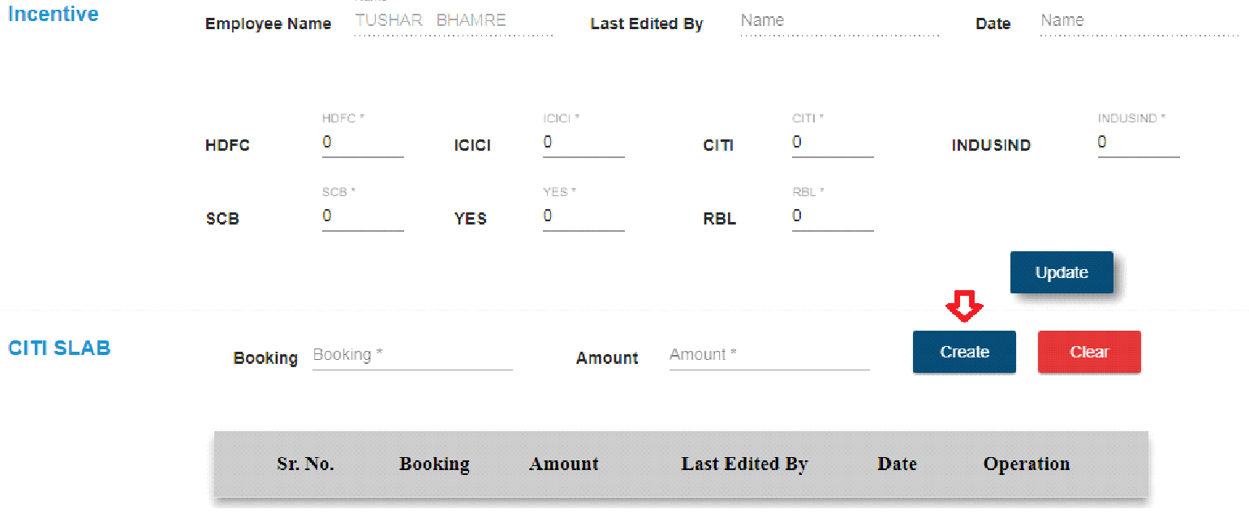

Fig. Team Manager Citi Target

**3) Process – SCB Salary Type – Target**

* Click on incentive operation of designation team manager with process SCB and salary type target.
* Enter booking.
* Enter amount.
* Click on create button.
* Click on approved button. Fig. Team Manager SCB Target

**4) Team Manager Salary Type – Non -Target**

* When user complete the target then salary will as it is.
* If user achieve target more than He/She get assigned then salary as per team manager excel sheet format and salary type non target.

**PL TME Incentive slab -**

* Click on incentive icon whose designation is PL TME
* **Cross Sell -** PL TME will get amount of cross sell of per card.
* For calculation,Enter per card amount and click the Update button.
* Approved this by superadmin.

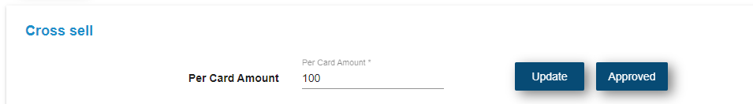

Fig.PL TME Cross Sell

* **Personal Loan Incentive slab -**
* Enter from amount and To Amount fields.
* Enter percentage field.
* Click on the Create button.
* Superadmin will approved the personal loan incentive slab.

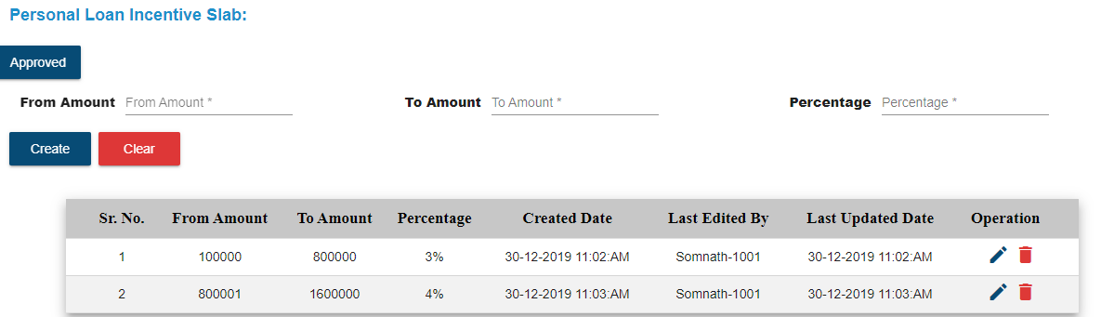

Fig.Personal Loan incentive slab

**PL Team Manager incentive -**

* Click on incentive icon whose designation is **PL Team Manager**
* Enter collection for team.
* Enter self lead
* Click on the Update button
* Approved by superadmin(Incentive will be calculated automatically in payroll module,Once its approved by superadmin)

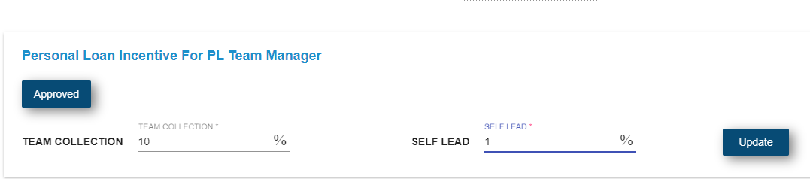

Fig.PL Team Manager Incentive slab

**Product Head incentive -**

Click on incentive icon in employee master whose designation is **Product Head**

* Enter collection for team.
* Click on the Update button
* Approved by superadmin(incentive will be calculated automatically in payroll module,Once its approved by superadmin)

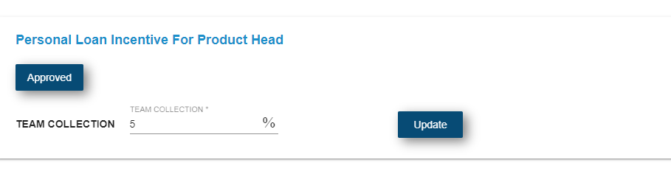

Fig.Product head incentive slab

**Unit Manager incentive -**

* Click on incentive icon in employee master whose designation is Unit Manager
* Open personal loan incentive for unit manager
* Enter team collection
* Enter self lead and click on the update button
* Approved it by superadmin (incentive will be calculated automatically in payroll module,Once its approved by superadmin)

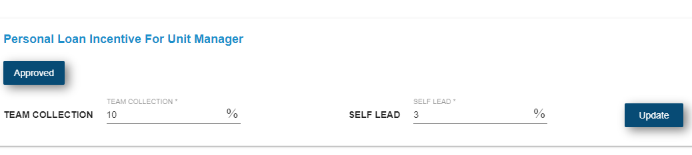

Fig.PL incentive slab for unit manager

**Back Office Executive Incentive -**

Click on incentive icon in employee master whose designation is **back office executive**

* Open personal loan incentive for Back office executive.
* Enter **From** amount field.
* Enter **To** amount and percentage and click on the create button.
* Approved it by superadmin (incentive will be calculated automatically in payroll module,Once its approved by superadmin)

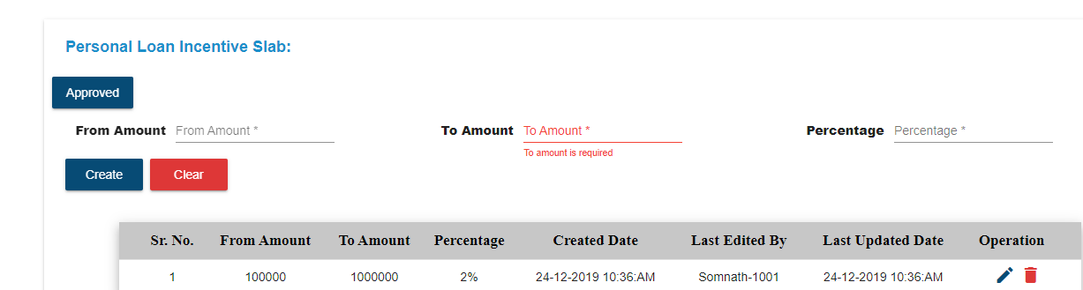

**Fig.back office executive incentive slab**

**MIS Executive Incentive -**

Click on incentive icon in employee master whose designation is **MIS Executive**

* Open personal loan incentive for MIS Executive.
* Enter **From Amount** field.
* Enter **To Amount** and click on the update button.
* Approved it by superadmin (incentive will be calculated automatically in payroll module,Once its approved by superadmin)

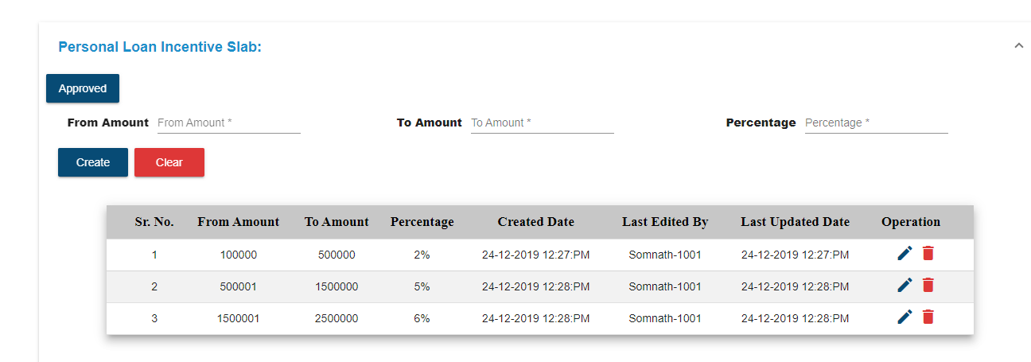

**Fig.MIS Executive incentive slab**

**D) Product Head Sub Module -**

* Click on Product Head sub module.
* Select product head name from dropdown.
* Select product head members and click on Assign button.
* In table view,you can see all assigned team product members.

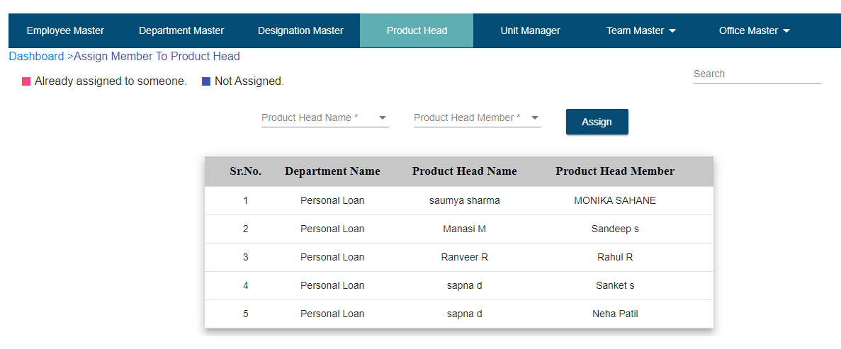

**Fig.Product Head**

**E) Unit Manager Sub Module -**

* Click on Unit manager sub module
* Select Unit manager name from dropdown
* Select unit manager members and click on Assign button
* In table view,you can see all assigned team product members.

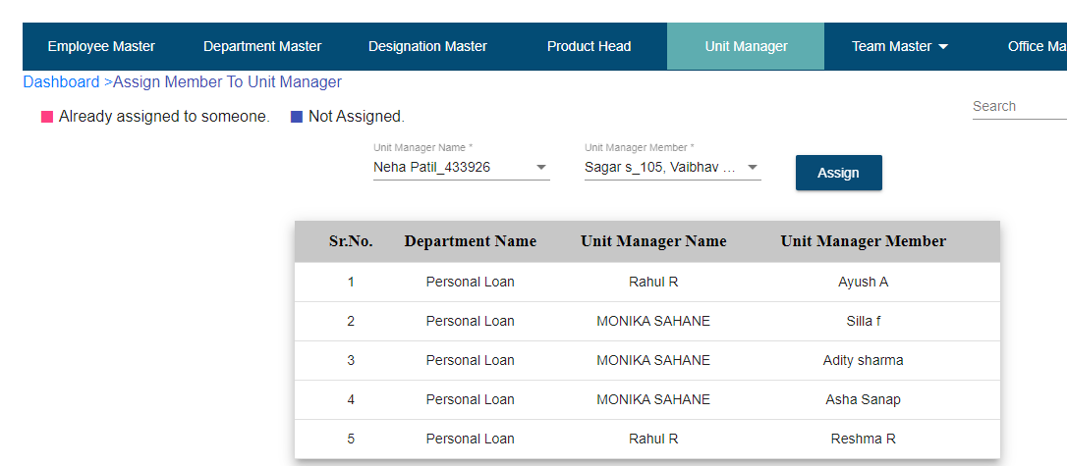

**Fig.Unit Manager**

**D) Team Master**

* Click on team master.

**1. Add Team Lead**

* Click on add team lead.
* Select department.
* Select user.
* Click on the add button.
* After adding team lead it will show in the team lead table.
* Click on the delete operation to delete the team lead record.

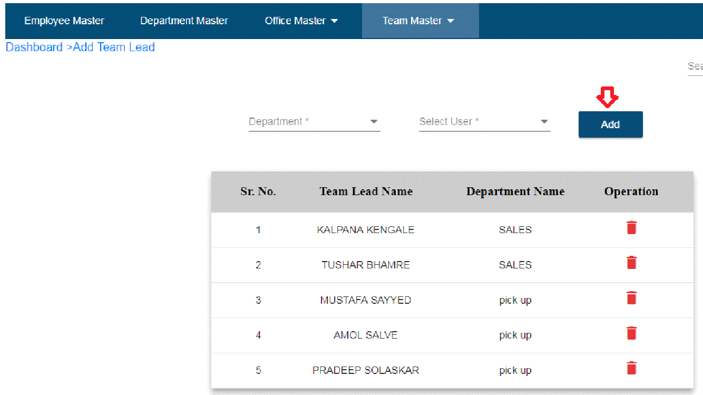

Fig. Add Team lead

**2. Add Team Member**

* Click on add team members.
* Select team lead name.
* Select team member.
* Click on assign button.
* After click on assign button, record will display in the table.
* Table display which team members assign to which team lead.

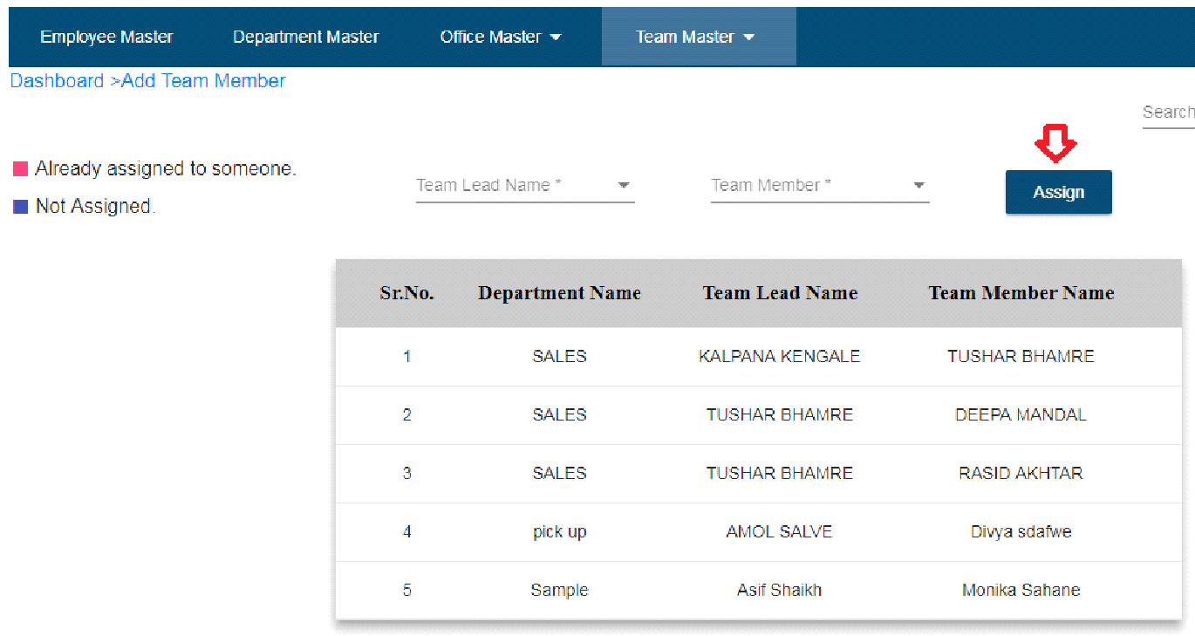

Fig. Assign Team member

* **Expense**
* Click on expense module.
* Only account and admin can add expense details.
* Super admin can only approve and reject the expense.

**A ) Expense Master**

* Click on expense master.
* Click on add expense button.
* Select team lead name.
* Enter expense name.
* Select date.
* Select expense category - First user need to add expense category from second sub

module expense category.

* Enter vendor name.
* Enter invoice number.
* Select mode of payment.
* Enter amount.
* Enter CGST.
* Enter SGST.
* Enter IGST.
* Select process.
* Select office location.
* Select sub office.
* Enter comments – not mandatory

Note: * indicates all fields are mandatory

* Select process.
* Click on create button.

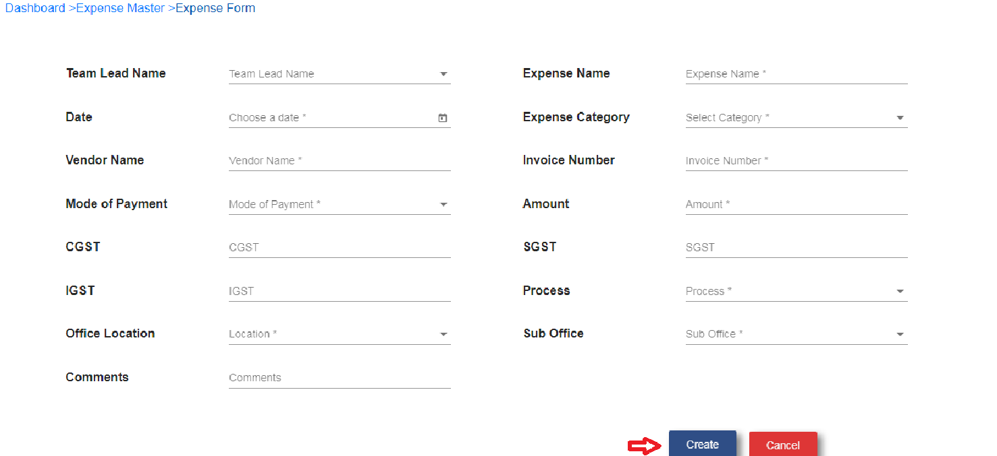

Fig. Expense form

* After click on create button expense record will show in the table.

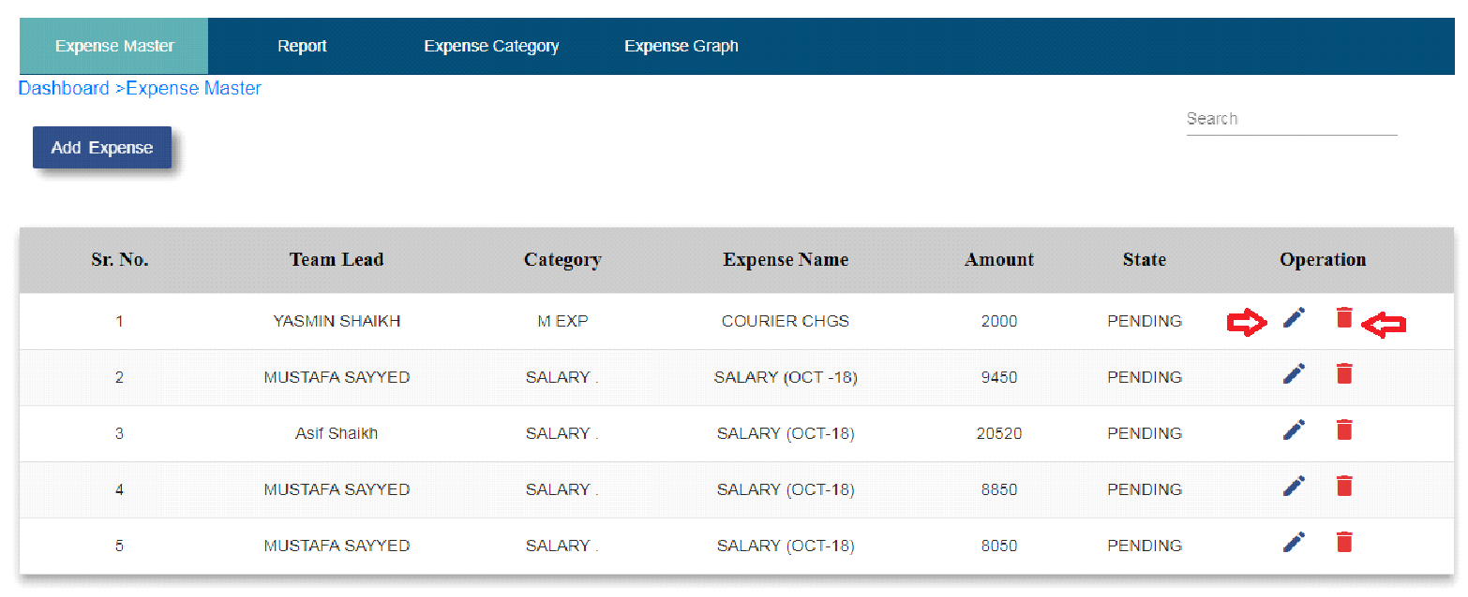

Fig. Expense Master Table

* Click on edit operation if user wants to edit expense details.
* Click on the delete operation if user wants to delete expense details.
* In expense master table expense status column is present.
* **Status :**

**1. Pending**

* When user added expense that time expense status will be pending.

**2. Approved**

* When super admin approve the expense then status will be approved.

**3. Rejected**

* When super admin reject the expense then status will be rejected.

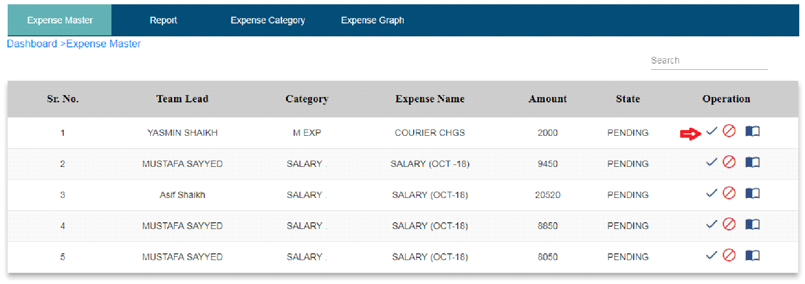

Fig. Super admin expense master

**B) Expense Category**

* Click on add expense category sub module.
* Click on the add category button.
* Enter category name.
* Click on create button.

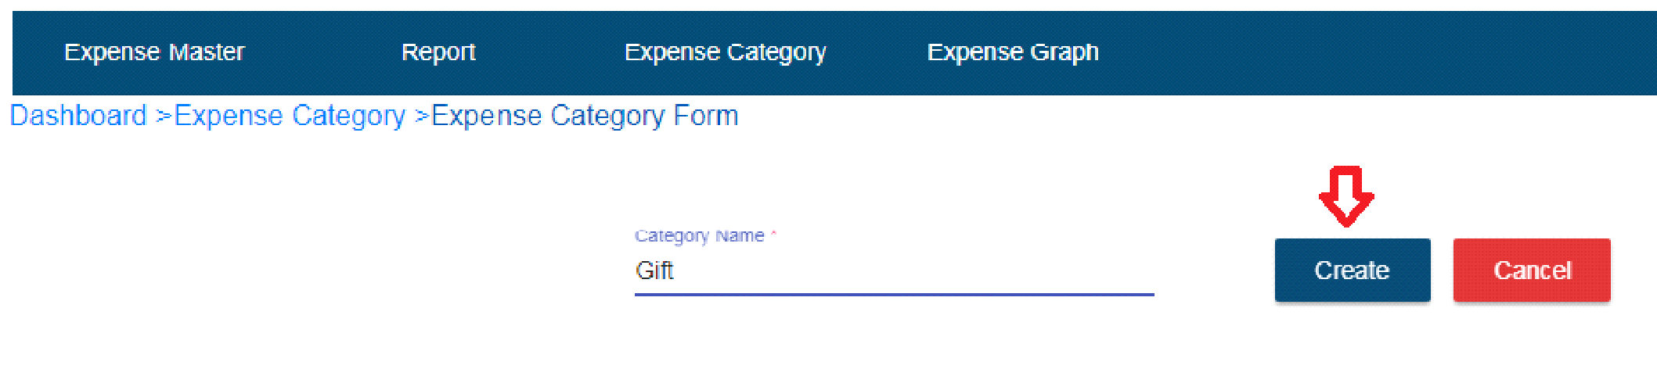

Fig. Expense Category

* After click on create button expense category will show in the table.
* If user wants to edit expense category name then click on edit operation.
* After that edit category name and click on the update button.
* If user doesn’t want to update category name then click on cancel button.
* Click on the delete operation if want to delete category name.

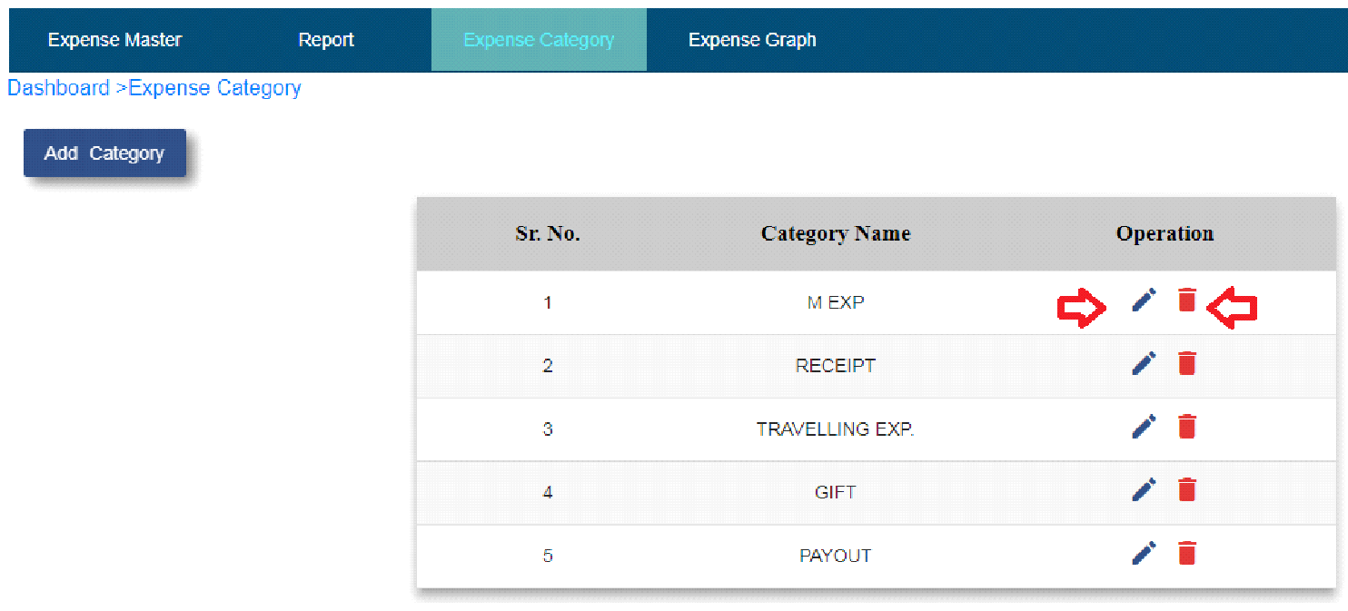

Fig. Expense category table

**C) Report**

* Click on report sub module.
* Expense report will display in this module.
* User can search record by selecting team lead name, department, date from,To date, location and process.
* Click on the search button it will display record related to search.
* Clear button is for clear the fields which user selected.
* Click on export report button – User will able to see expense report in excel sheet format.

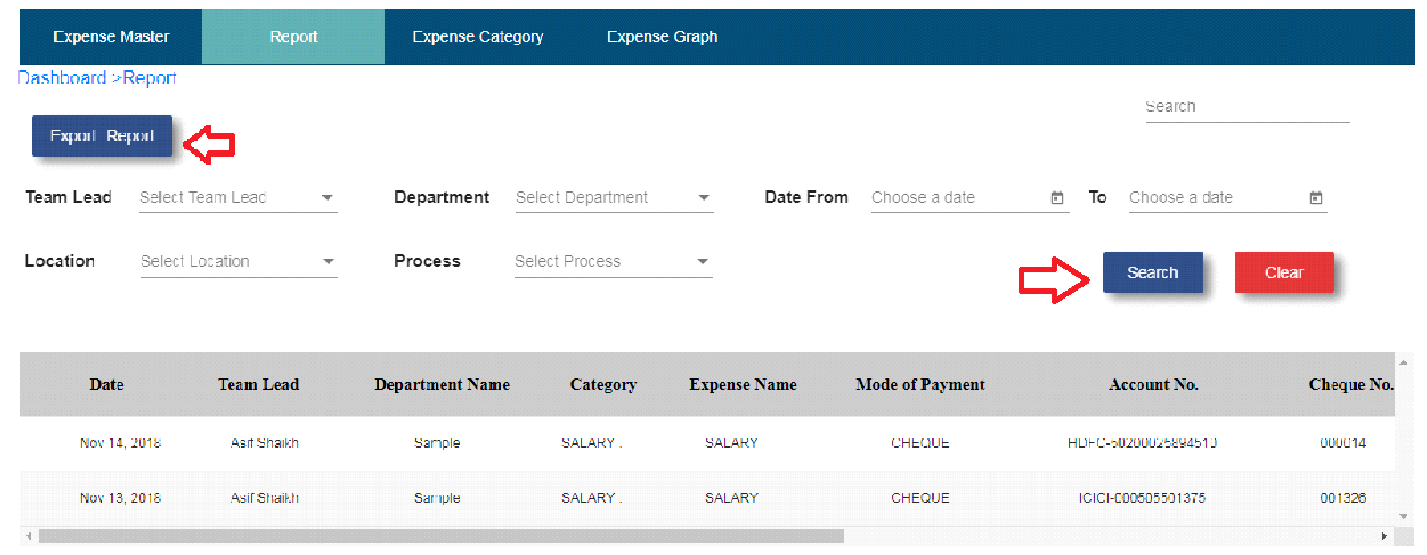

Fig. Expense Report

**D) Expense Graph**

* Click on expense graph sub module.
* Graph will be display.
* Choose date from.
* Choose date to.
* Click on the search button.
* Graph display record related to that search.
* Clear button clear the date.

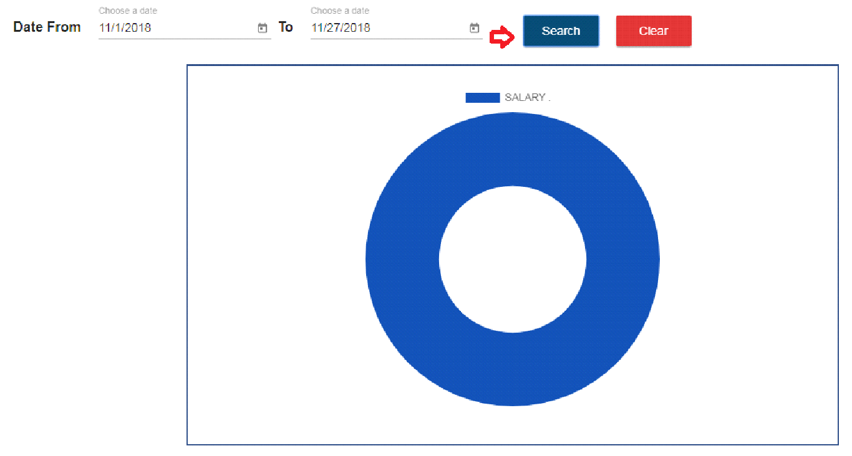

Fig. Expense Graph

**6. Attendance**

Note: 1. Need biometric device

2. User’s login should be present in biometric device with same employee id and

password.

3. To view daily attendance , Hierarchy should be like Product head -> Unit manager -> Team Lead ->Team member.

**1. Daily Attendance**

* Click on attendance module.
* Attendance table will display.
* Product head name field will present in daily attendance.
* Total column display a count of how many members has to that product head.
* When user punching in biometric device it will display in office column and also in view attendance present column.
* When user punching out in biometric device it will display in Out office column and also in view attendance absent column.
* When users punch in biometric,multiple times then entry will be shown in attendance master table.
* Total column shows count according to In office and Out office column entry.

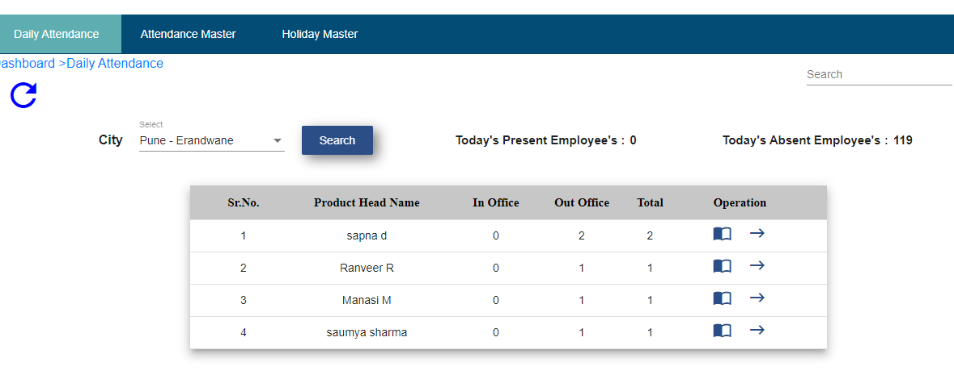

**Fig. Product head attendance view**

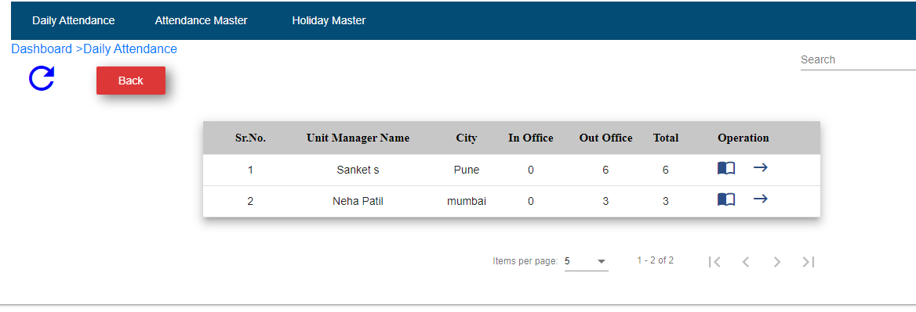

**Fig.Unit manager attendance view**

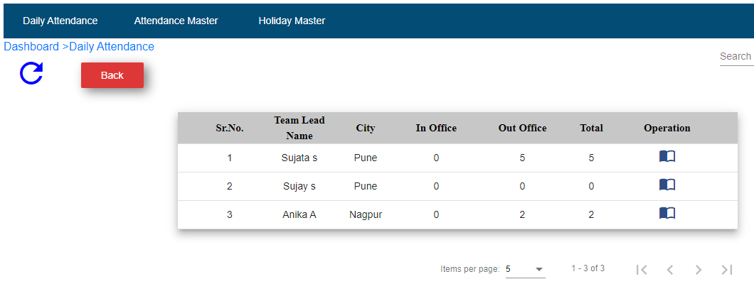

**Fig.Team Lead attendance view**

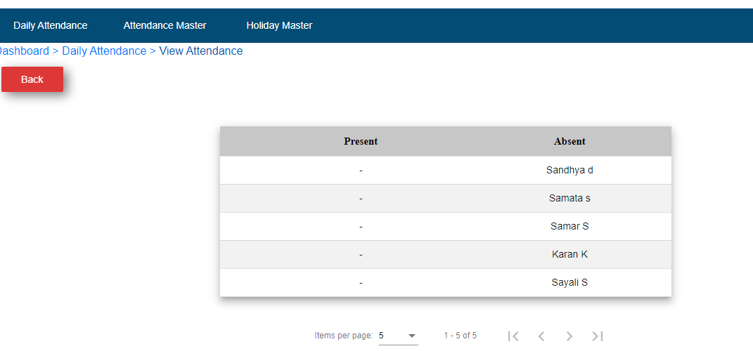

Fig.Present and absent View Attendance

**2. Attendance Master -**

* Click on attendance master.
* Attendance master table will show all users details.
* Click on view details operation.

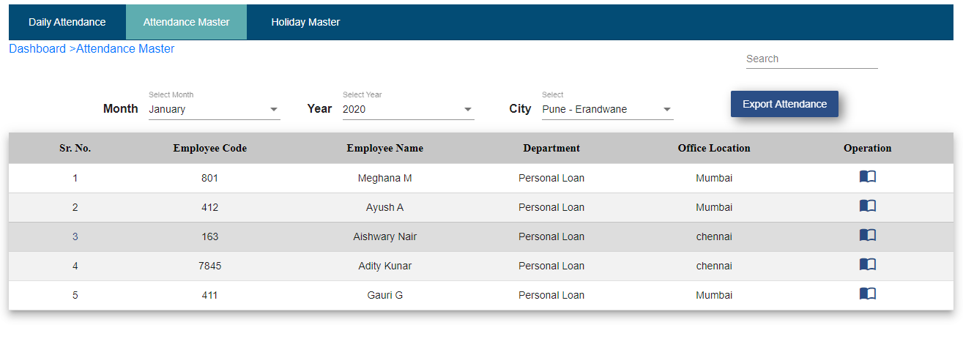

**Fig. Attendance Master**

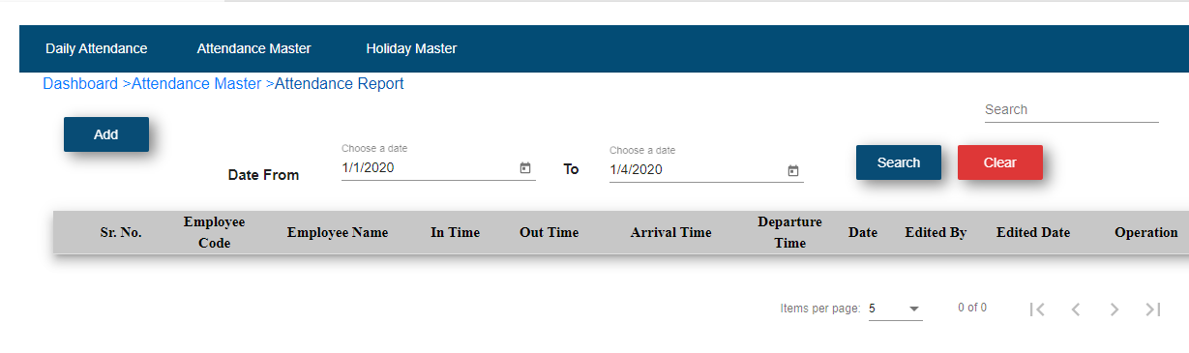

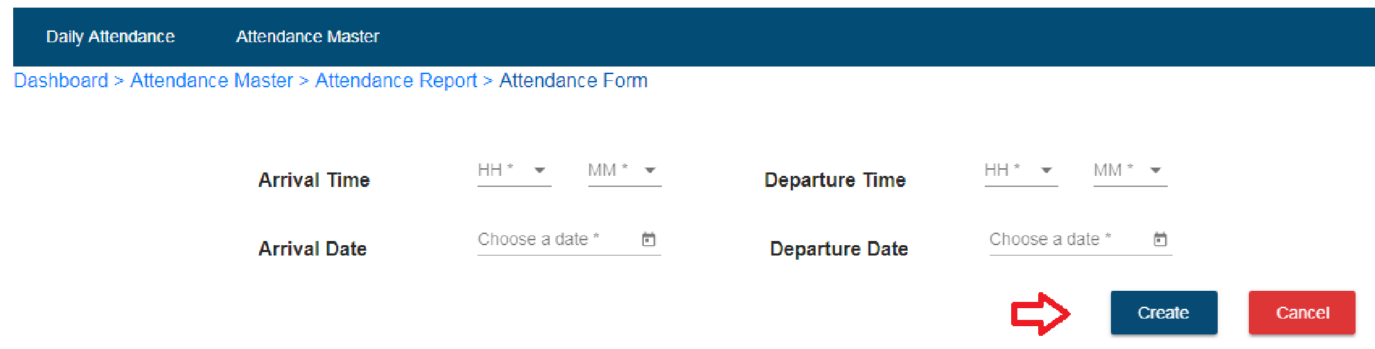

Fig. Attendance Form

* Click on the add button.
* If user wants to add attendance manually then click on the add button.
* Select arrival time.
* Select departure time.
* Select arrival date.
* Select departure date.
* Click on create button.
* After click on create button record will be displayed in attendance master table.
* If user wants to edit particular record then click on edit operation and edit details and click on the update button.

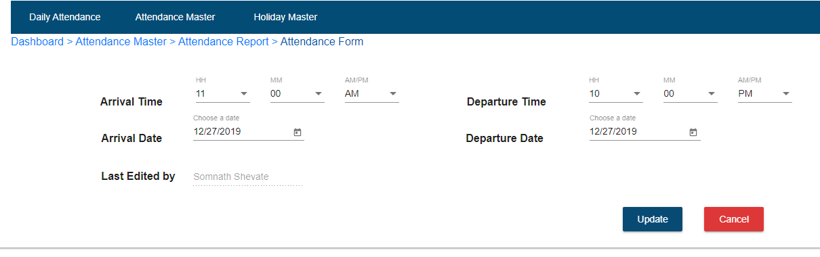

**3. Holiday Master-**



In Holiday Master, there is holiday manager, user is able to add holidays. To add holidays follow below steps: -

* Choose Date
* Day get auto generated
* Enter reason
* Select Location
* Click on Add button
* Added holidays displayed in Holiday master table
* User is able to see holidays location wise by using search functionality.
* Select Date from
* Select date to
* Select Location
* Click on Search
* Now you can see the all holidays of selected date and location.
* If you add holiday, holiday is enable, in operation column icon is blue and at right side. In case holiday get cancel then you click on that icon then holiday get disabled, icon get white and shift in left

**7. MIS**

* Click on MIS module.

**a) Card Master**

* Click on card master sub module.
* Click on add button.
* Select bank name.
* Enter card type.
* Enter CSA card points.
* Enter logo – For ICICI bank
* Click on create button.

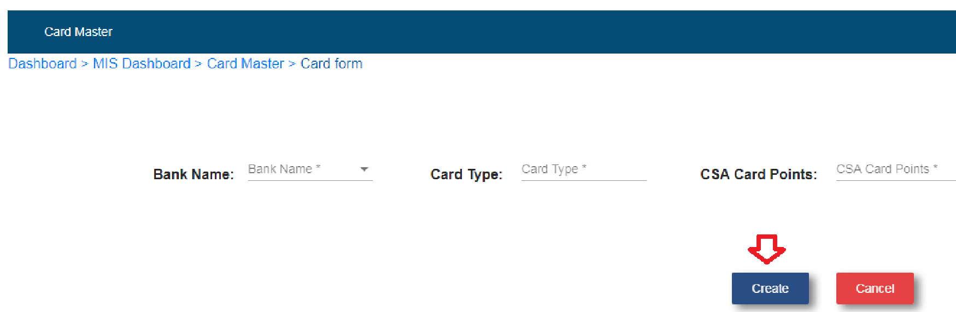

Fig. Card Master

* After click on create button cards details show in the card master table.
* If user wants to edit card details then click on edit operation.
* After that edit card details and click on update button.
* If user wants to delete card details then click on delete operation.

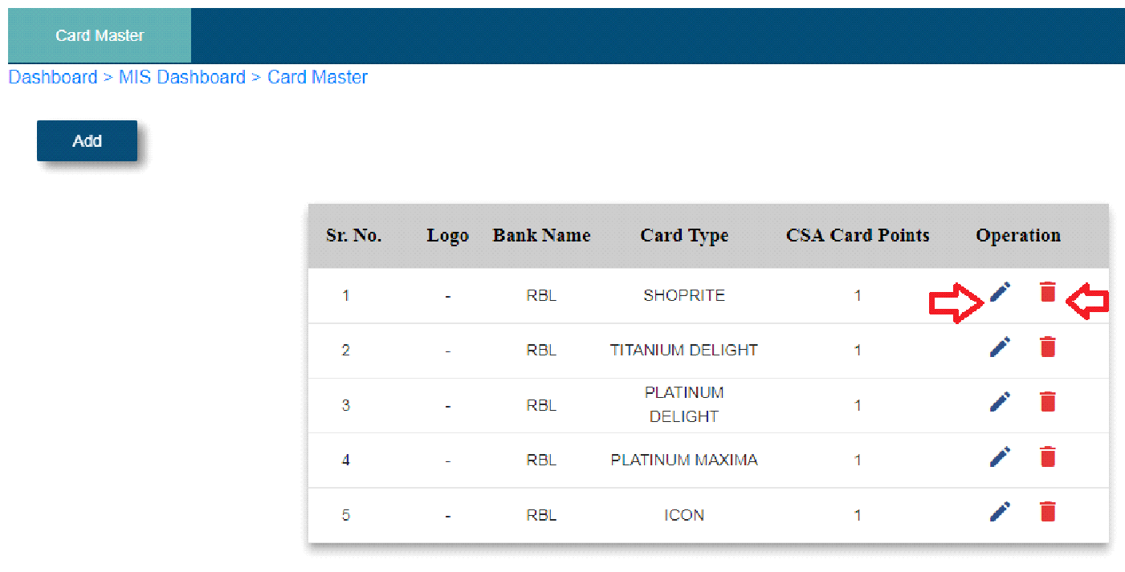

Fig. Card Master Table

**b) Lead Sheet**

* Before filling the lead sheet form, add user with designation pick up executive and TME in configuration module.
* After that fill the lead sheet form with that pick up executive and TME names.

Note: CSA Name = TME Name

* Click on add lead button.
* Application number field will disable. Once pickup executive collect all documents to that particular user through the app then application number will be auto generated.
* Select date.
* Select time HH: MM.
* Select pick up executive name.
* Select CSA Name.
* **Customer Details**
* Enter customer name.
* Enter mobile number – Enter only 10 digits
* Enter appointment address.
* Select office or residence.
* Enter landmark.
* Enter designation.
* Enter company name.
* Enter company area.
* Enter gross salary.
* Enter net salary.
* Enter office number - not mandatory
* Enter residential area.

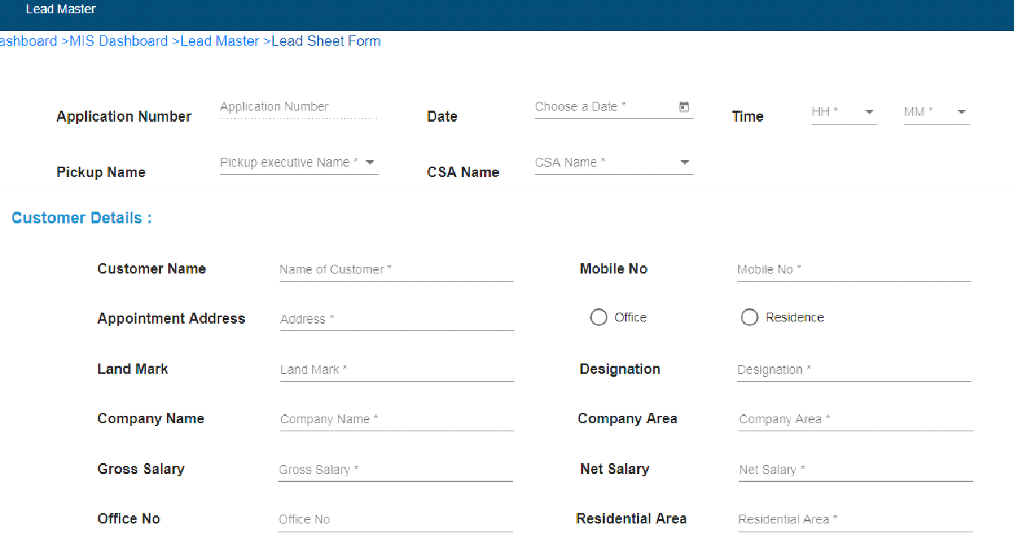

Fig. Lead sheet Form1

* **Document Area**
* Enter salary account bank name
* Select photo or visiting card
* Select ID proof
* Pan card
* Adhar card
* Passport
* Company ID
* Driving license
* Voter Id
* Select Address proof
* Voter Id
* Passport
* Passbook
* Adhar card
* Electricity bill
* Mobile bill
* Index II
* Gas receipt
* Telephone bill
* Driving licenses
* Gas passbook
* Registered rent agreement
* Select bank statement(months)
* Company letterhead
* Income proof
* Salary slip(months)
* Bank statement
* ITR SET
* Credit card statement
* Others
* PL agreement
* Cheque
* Cancel cheque

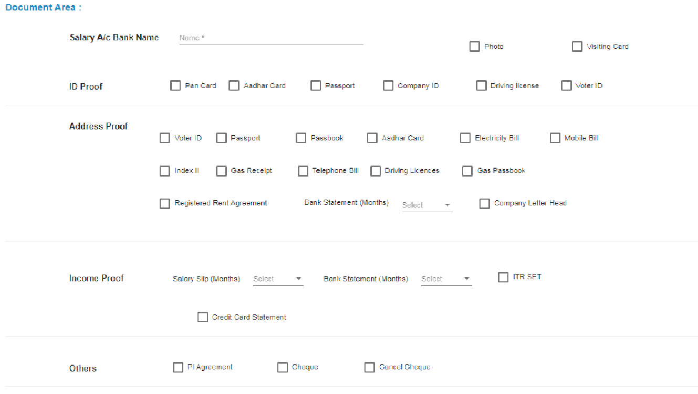

Fig. Lead sheet Form2

* **Card Type**
* Select bank name
* Select card type

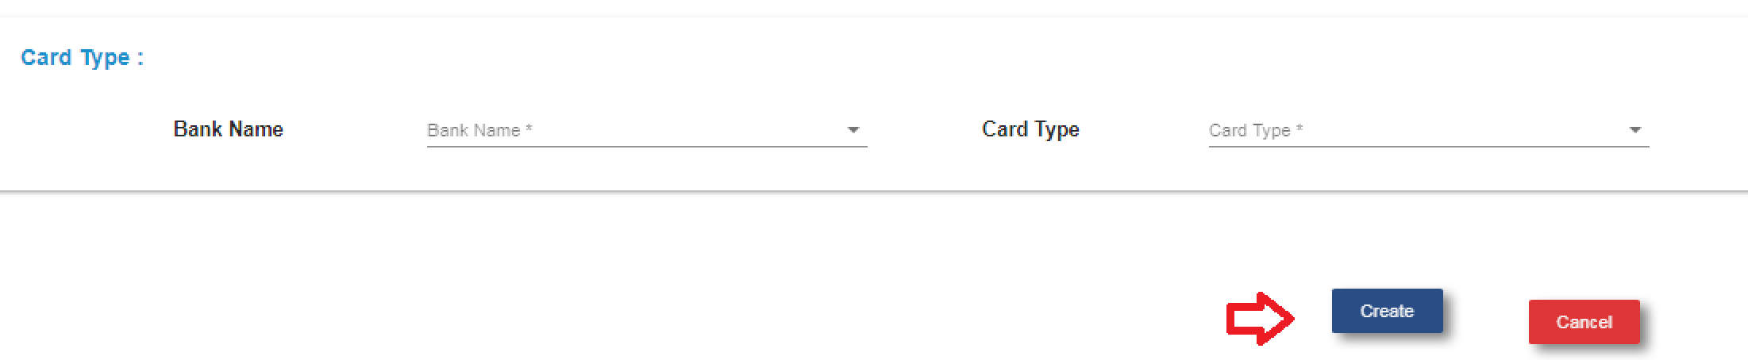

Fig. Lead sheet Form3

* Click on create button.
* After click on create button, customer details display in the app to that particular pick up executive which TME selected while filling this lead sheet form.

**App**

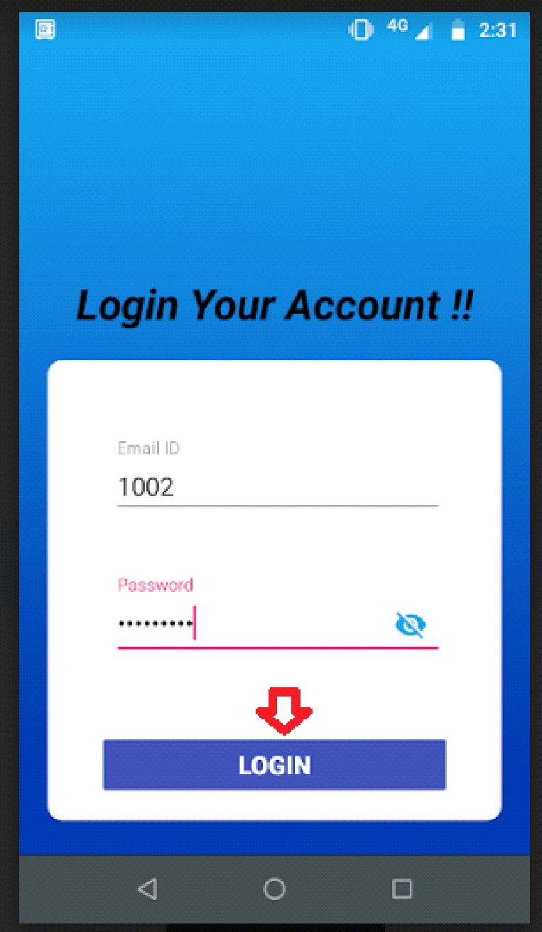

Fig. App Login

* When pick up executive login the app he/ she is able to see profile details by clicking on profile tab.

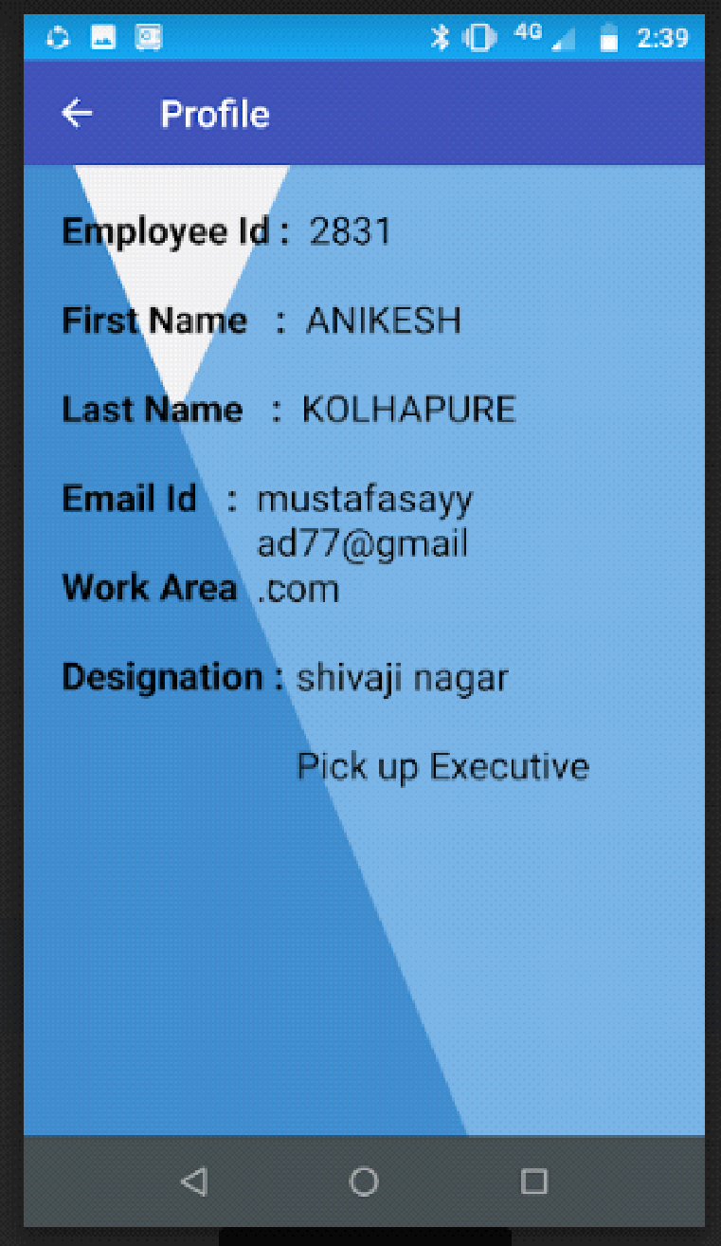

Fig. App Profile

* Click on task tab.

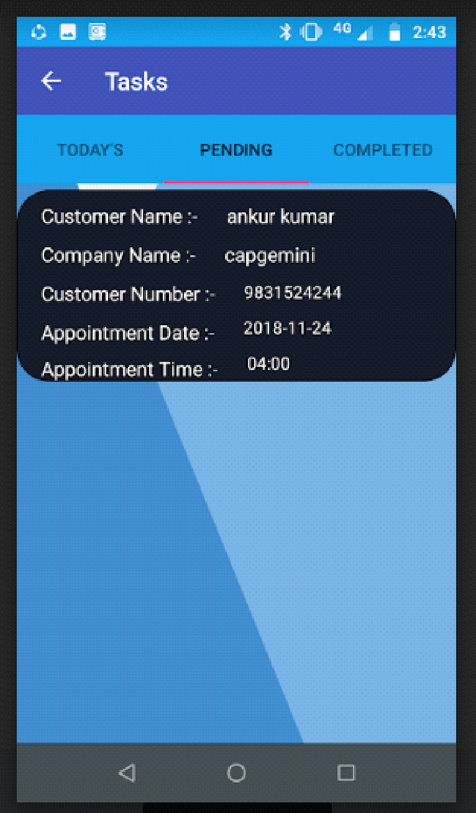

Fig. App task

* Click on pending sub tab.
* Click on customer name.
* Enter employee Id.
* Click on next

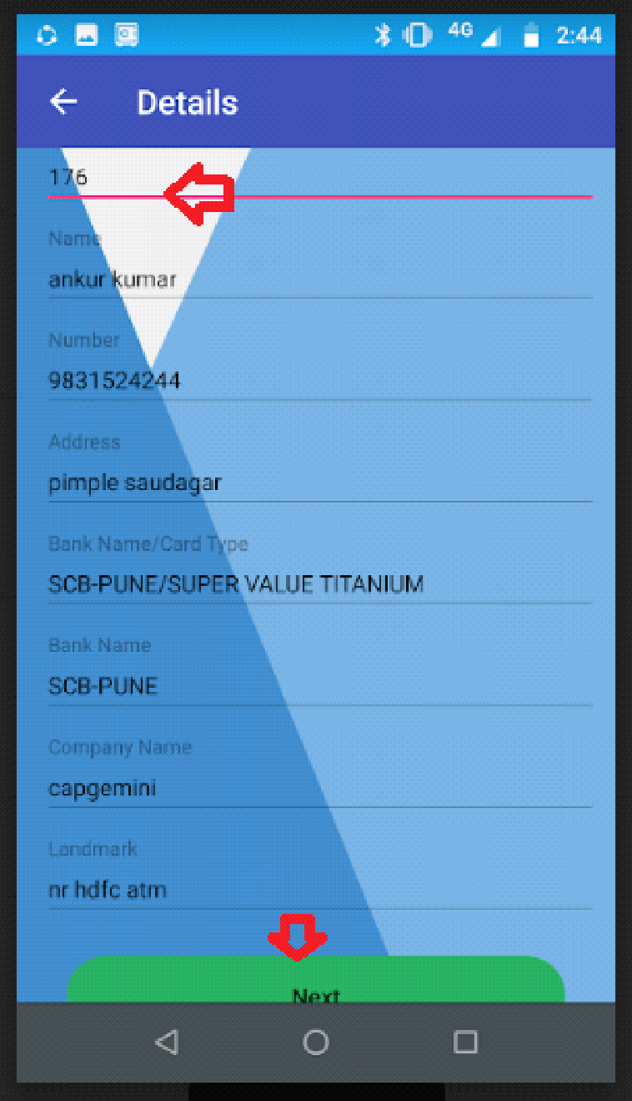

Fig. APP Customer Details

* Select documents.
* Click on Id proof, address proof, income proof and others proof.
* Select documents and click on save button.

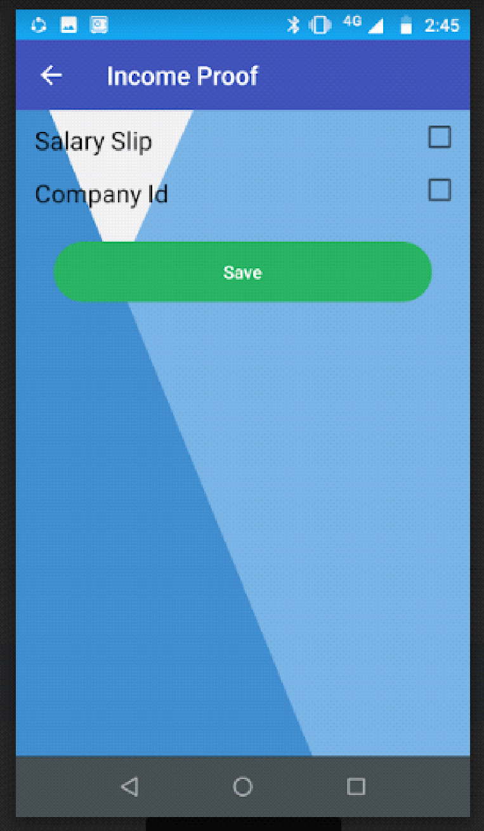

Fig. App documents proof

* Click on submit button.

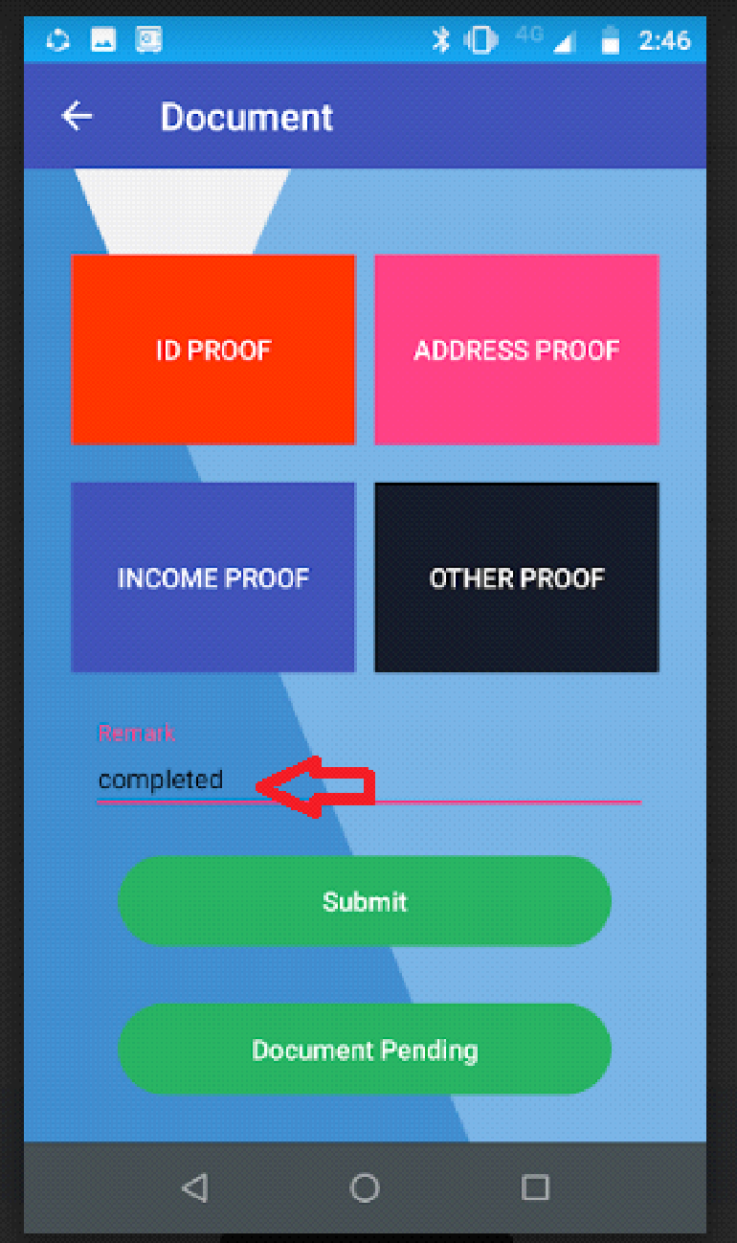

Fig. submit button

* Click on completed tab – all completed customer details display

**Self**

* Click on self tab – If pick up executive wants to add self customer details
* Enter application number.
* Enter name.
* Enter number.
* Enter address.
* Select bank name/card type.
* Enter company name.
* Click on submit.

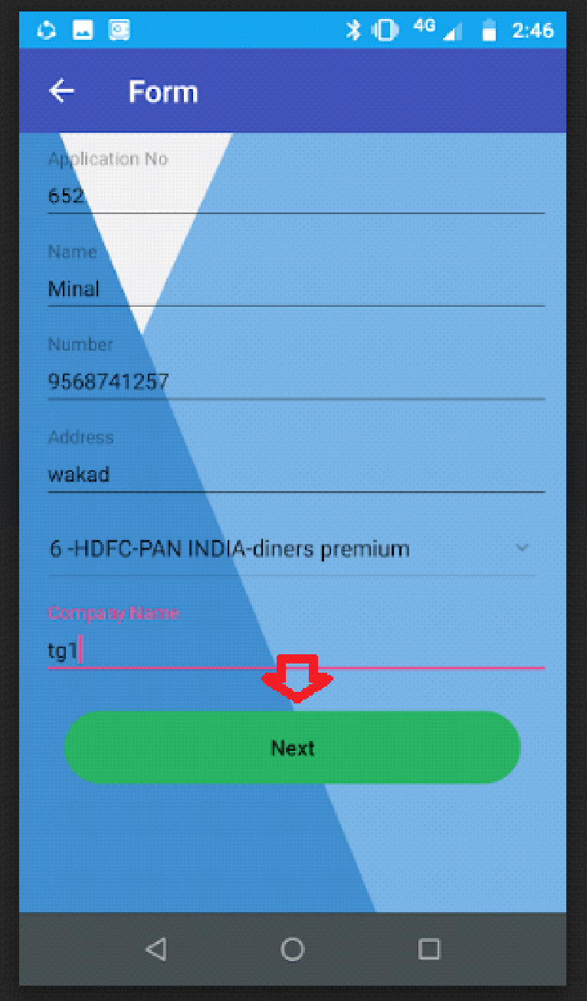

Fig. App Self form

* Click on ID proof – Select documents
* Click on save.
* Click on address proof – Select documents
* Click on save.
* Click on income proof – Select documents
* Click on save.
* Click on other proof – Select documents
* Click on save.

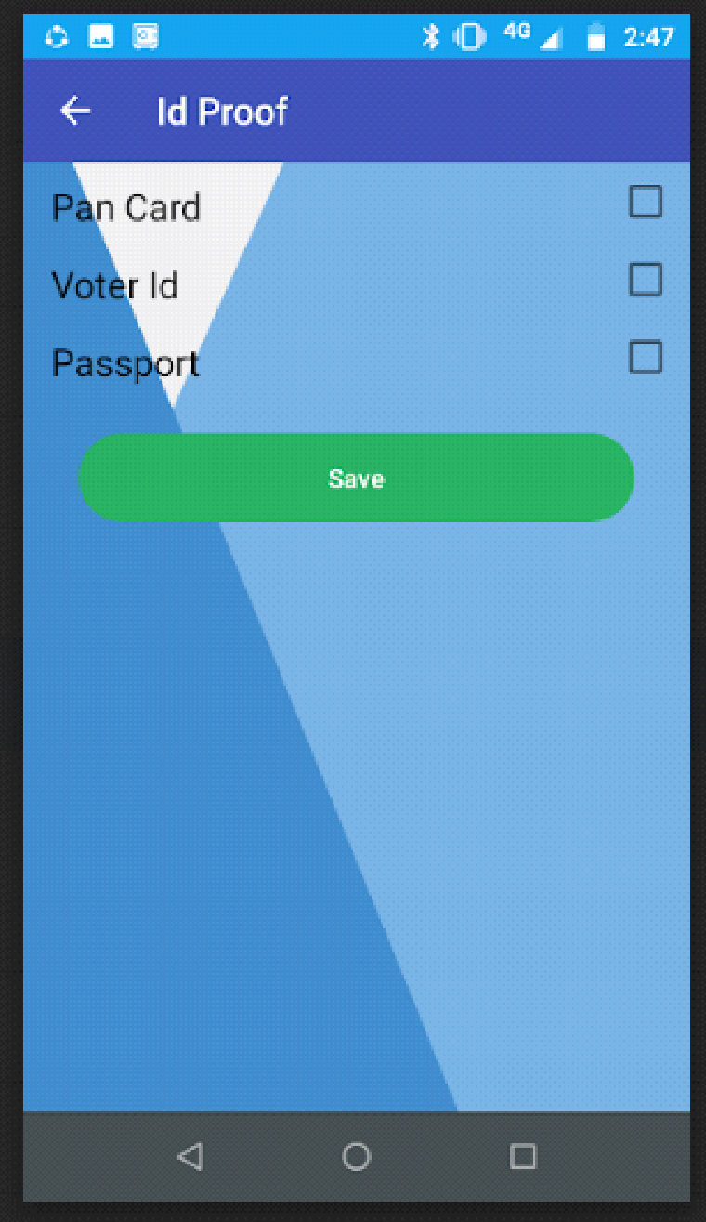

Fig. App Self Income proof

* Enter remark – not mandatory
* Click on submit button – After that record display in export master table
* Click on logout button.

**C) Credit Card MIS Export**

* Click on credit card MIS export sub module.
* **Master Table**
* Click on credit card MIS export.
* Click on edit operation.

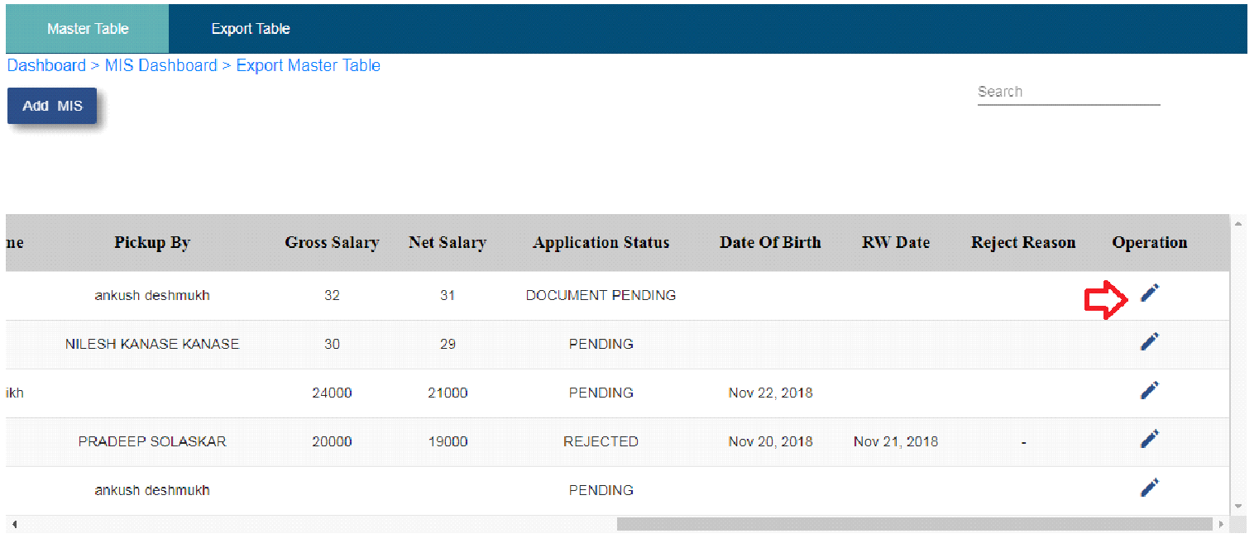

Fig. Export Master Table Edit

* Enter all enable and mandatory fields.
* Select verify by field.
* Select check by field.
* Select fill up by field.
* Select application status :

1. STB – Record display in export table

2. Pending – Record display in master table

3. Document pending – Record display in master table

4. Rejected – Record display in master table

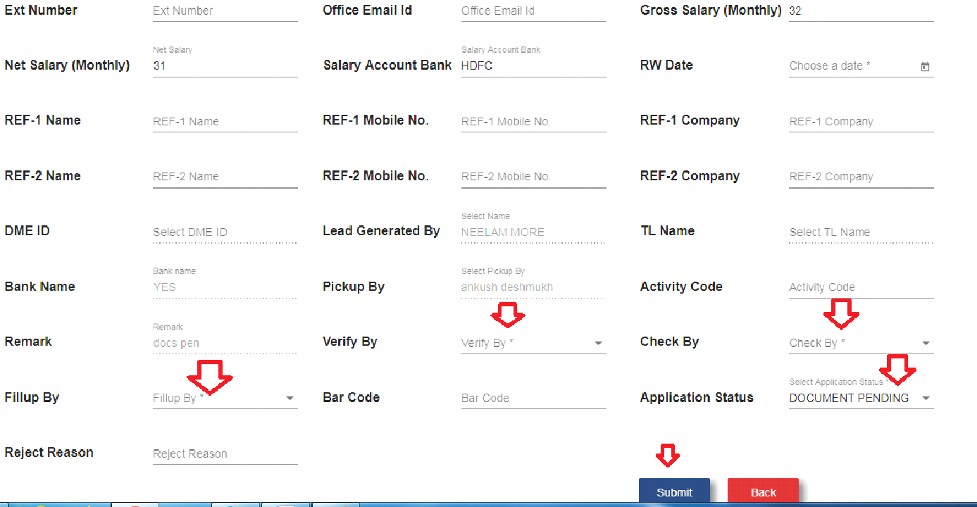

Fig. MIS Export Master Form

* **Export Table**
* Click on view details operation – Customer details display
* Select date from date, date to and bank name.
* Click on search button.
* Click on export report – Report display into the excel sheet format

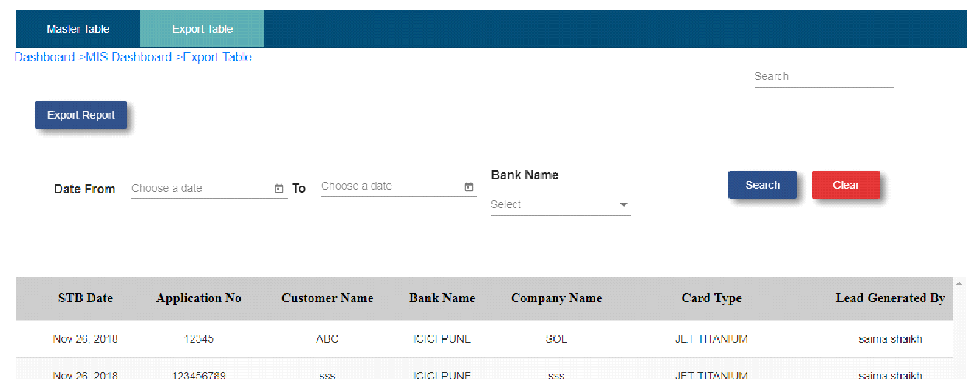

Fig. Export Table

* **Remaining Master Table**
* Click on add MIS button.
* Before filling this form add user with designation FOS in configuration module.

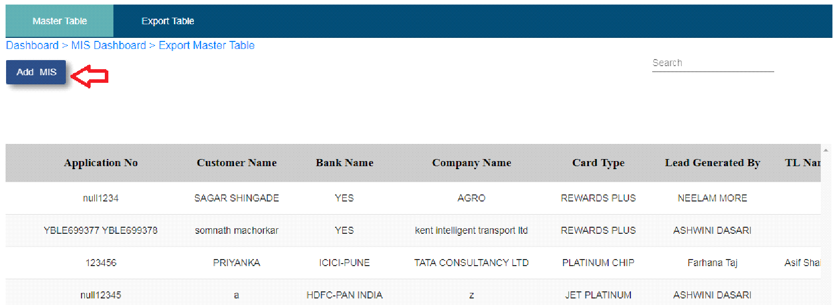

Fig. Add MIS

* Enter application number.
* Select bank name.
* Select card type.
* Select lead generated by.
* Select pick up date.
* Enter customer name.
* Enter personal email id.
* Enter present address.
* Enter mobile number.
* Enter P add contact number. –Not mandatory
* Select marital status.
* Select date of birth.
* Enter education.
* Enter PAN number.
* Enter company category.
* Enter company name.
* Enter company code.
* Enter office landline number – Not mandatory
* Enter Ext number – Not mandatory
* Enter office email id – not mandatory
* Enter gross salary(monthly)
* Enter net salary(monthly)
* Enter adhar number
* Enter salary account bank.
* Select RW date.
* Enter REF -1 name.
* Enter REF – 1 mobile number.
* Enter REF – 1 Company.
* Enter REF - 2 name.
* Enter REF – 2 mobile number.
* Enter REF – 2 Company.
* Enter activity code.
* Enter remark.
* Enter bar code.
* Click on submit button.

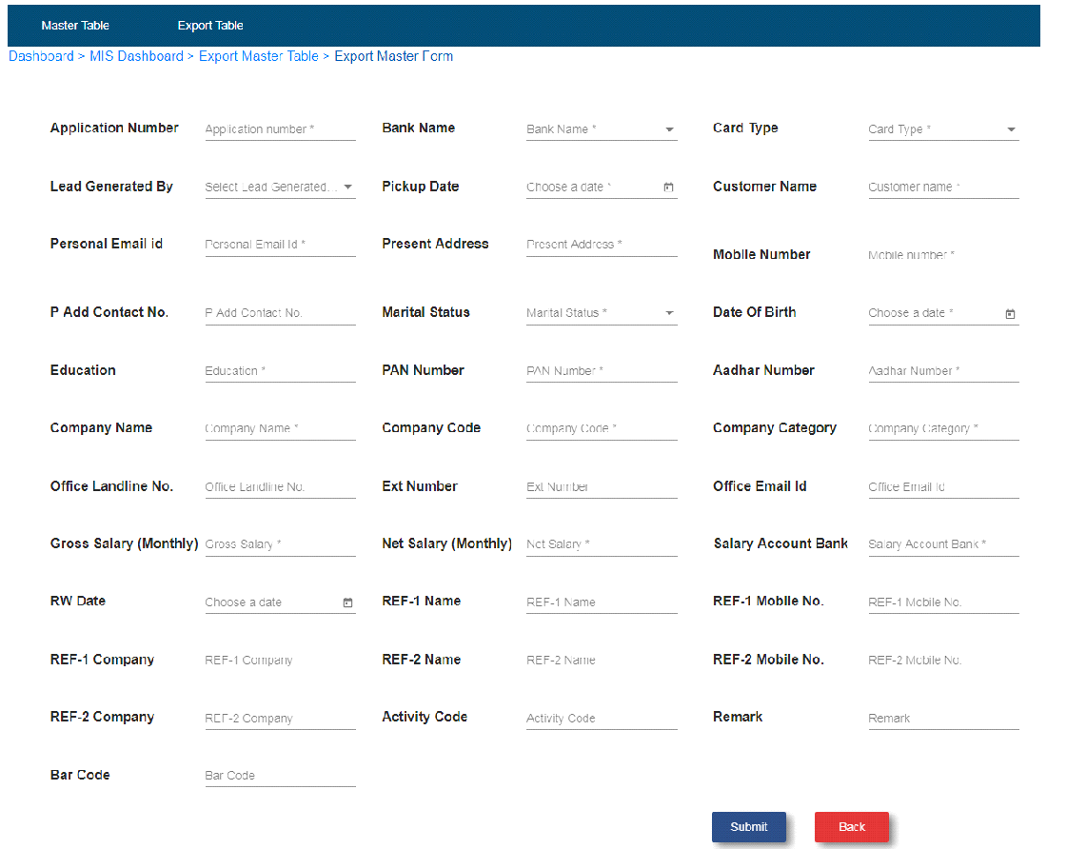

Fig. Add MIS Form

* After click on submit button it will show in the master table.
* Click on edit operation.
* Enter all enable and mandatory fields.
* Select verify by.
* Select check by.
* Select application status :
* 1. STB – Record display in export table
* 2. Pending – Record display in master table
* 3. Document pending – Record display in master table
* 4. Rejected – Record display in master table

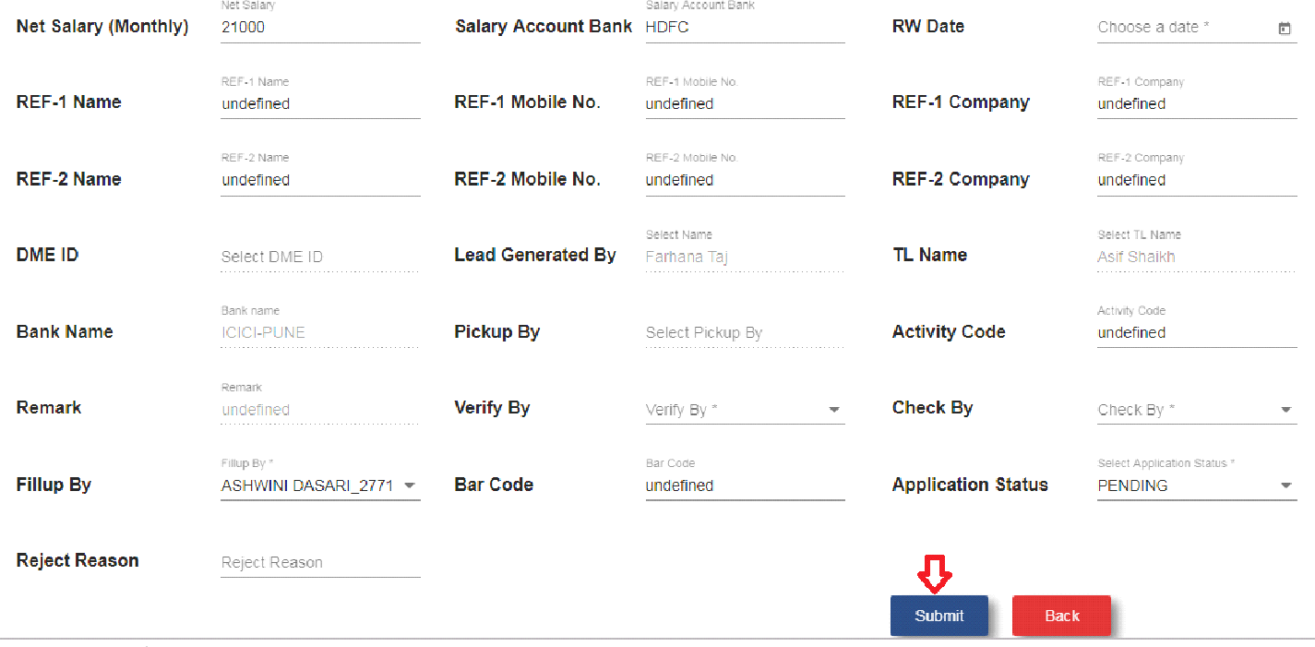

Fig. Add MIS FOS Edit Form

**C) Credit Card MIS Import**

* Click on credit card MIS import sub module.

Note: 1. While uploading the excel sheet, file format should be same as bank sent to company.

2. Upload file format should be as follows:

|  |  |  |  |  |  |  |
| --- | --- | --- | --- | --- | --- | --- |
| APPLICATION NO | CUSTOMER NAME | Decision Date | Application Status | Rejection Remark | Decline Code | LOGO(CARD TYPE) |

3. DIP upload file format should be as follows:

|  |  |  |  |
| --- | --- | --- | --- |
| APPLICATION NO | CUSTOMER NAME | Decision Date | DIP Status |

4. Decision date in the file must be in “YYYY/MM/DD” format.

5. While uploading booking and DIP ok sheet, file extension must be in .xlsx .

6. Excel sheet converts application number like 00123 to 123 there for it mismatches the application number and particular record go to the error log. So application number should not start from ‘0’.

5. If application number is greater than 10 then excel sheet will convert it into scientific notation as 1.2408E+12 and which will not matching with application number. So particular record will go to error log. So user need to convert the excel sheet cell into proper format.

**1. Upload**

* Click on upload tab.

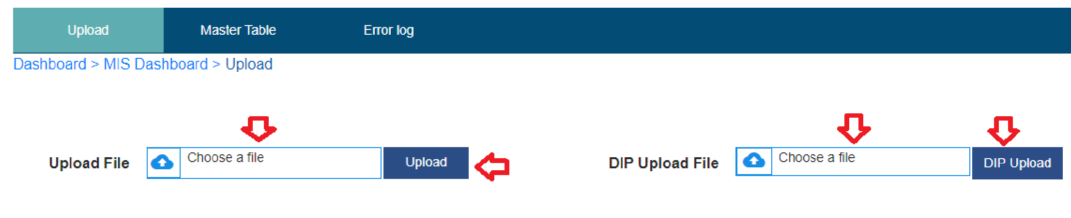

Fig. Import Upload and DIP Upload

* Choose a file.
* Click on upload button.
* Record will show in master table.
* Click on DIP.
* Choose a file.
* Click on DIP upload button.
* Record will show in master table

**2. Master Table**

* After uploading and DIP uploading the file, records will show in master table.
* Click on date from and date to.
* Select bank name.
* Select status.
* Click on search.
* After click on search button, particular record related to that search will display.

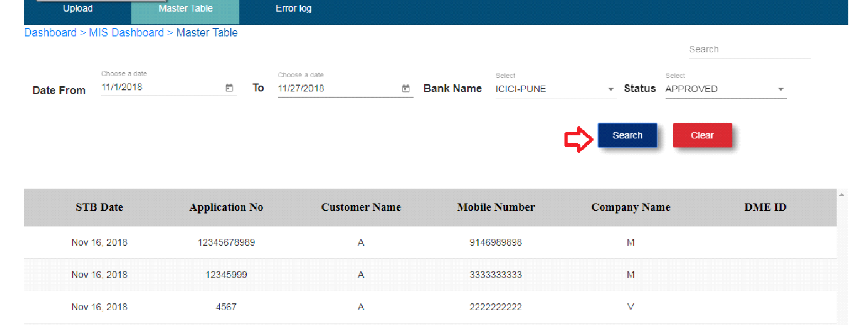

Fig. Import Master table

**3. Error Log**

* Click on error log.
* If application number mismatches in excel sheet then it will go to error log.
* Select date from and date to.
* Click on search button.
* After click on search button particular record will display.

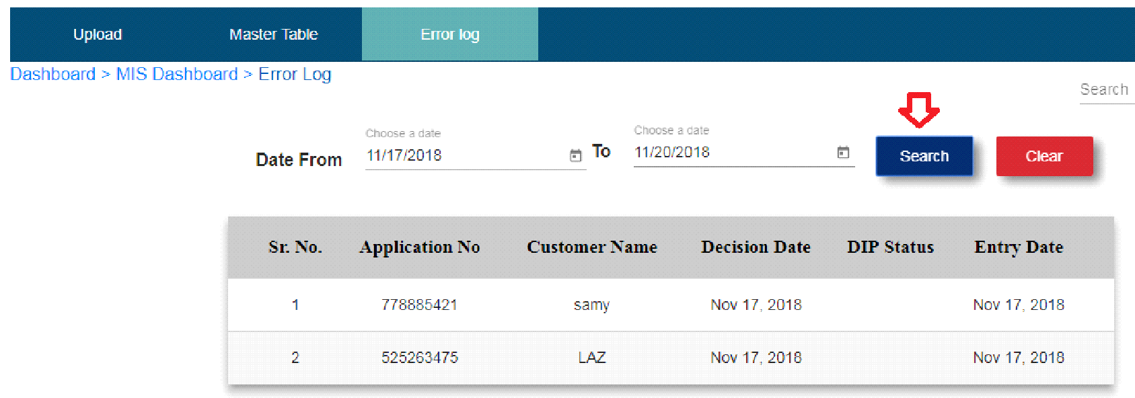

Fig. Error Log

**8. Stock Management**

* Click on stock management module.

**1. Stock Report**

* Click on add stock.
* Enter stock item name.
* Select date.
* Enter stock type.
* Enter new purchase.
* Enter amount.
* Click on create button.

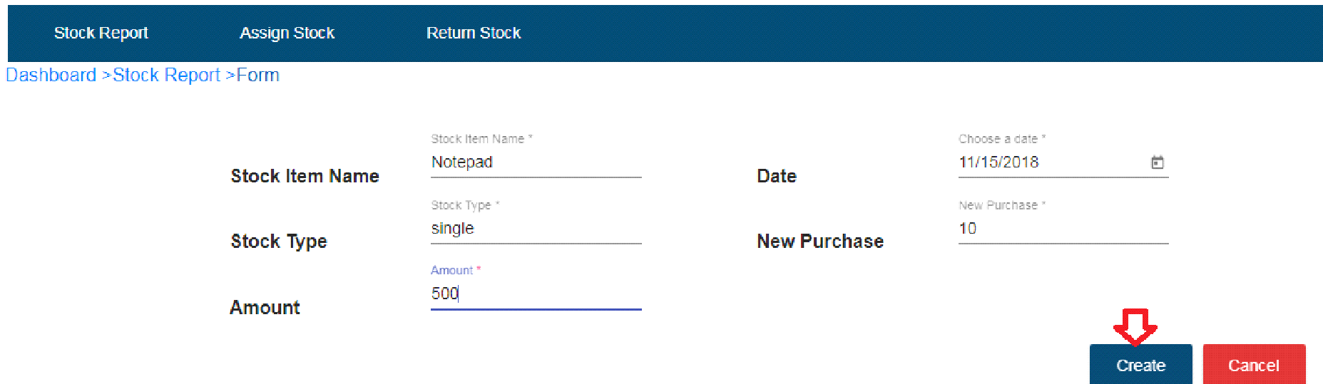

Fig. Add Stock

* After click on create button, record will save in stock report table.
* If user wants to add more stock then click on edit operation.
* Enter new purchase.
* Enter amount.
* Click on update button.

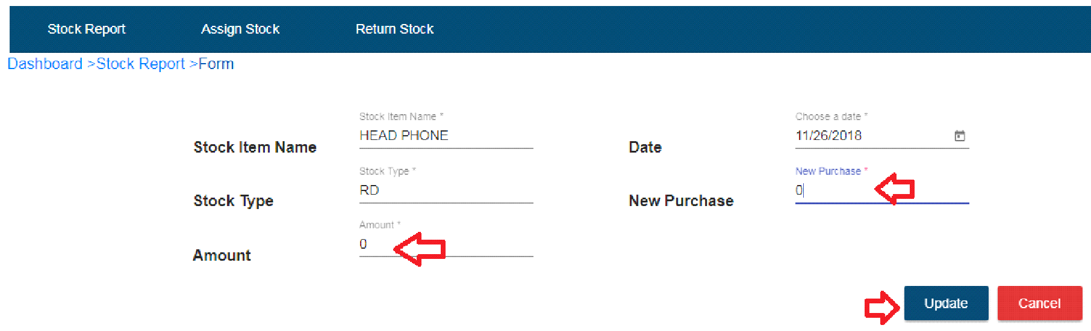

Fig. New stock

* If user wants to add same stock again and again then click on edit operation and update there.
* After adding new stock, it will display in stock report table.
* Click on date from, date to and item name.
* Click on search button
* After click on search button, record will be display.

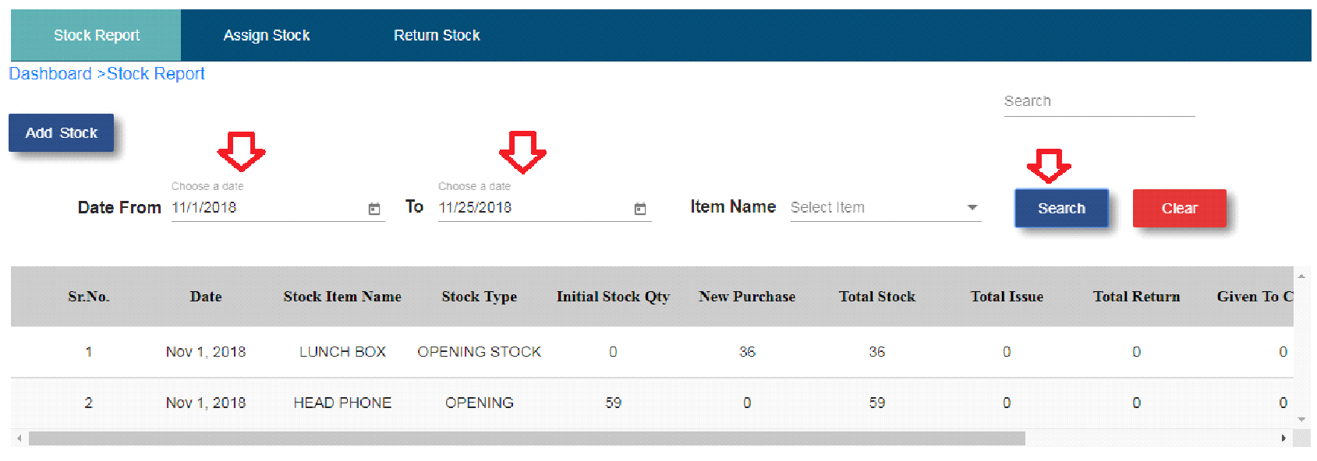

Fig. Search Stock Record

**2. Assign Stock**

* Click on assign stock sub module.
* Click on add assign button.
* Choose date.
* Select team manager.
* Select employee name.
* Select process.
* Select items.
* Enter quantity.
* Amount will be auto calculate.
* Office will be auto select.
* Sub office will be auto select.
* Select assigned by.
* Enter activity name.
* Click on create button.

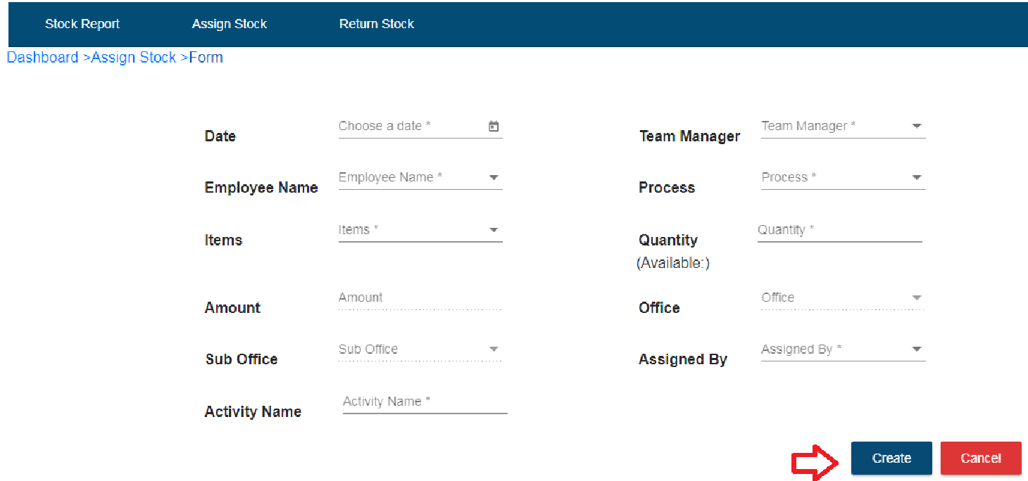

Fig. Assign Stock

* After click on create button record will be display in assign stock table.
* If user wants to see details of assigned stock then click on view details operation.

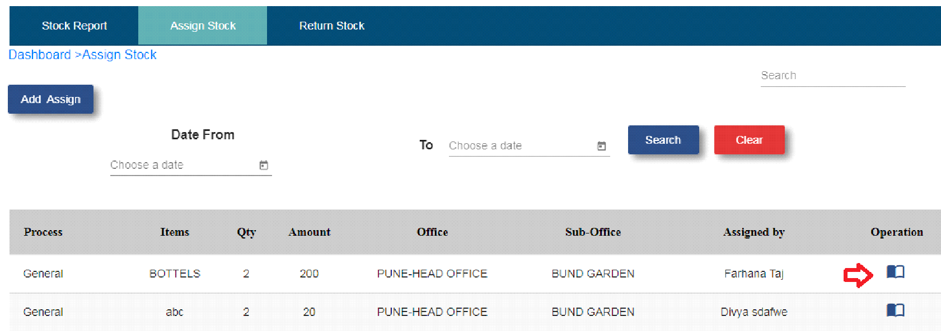

Fig. Assign Stock View Operation

* Click on date from and date to.
* Click on search button.
* After click on search button particular record will display.

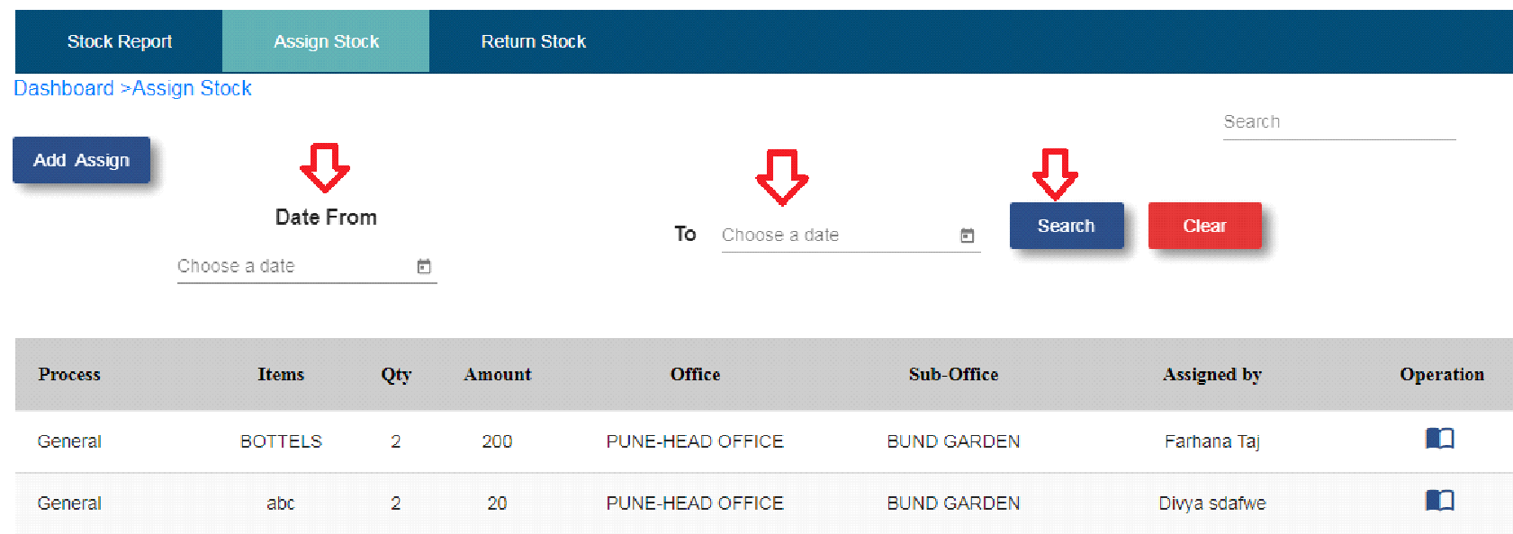

Fig. Assign Stock search button

**3. Return Stock**

* Click on return stock sub module.
* Click on return stock button.
* Select employee name.
* Select stock item name.
* Enter return quantity.
* Select return date.
* Select received by.
* Click on submit button.

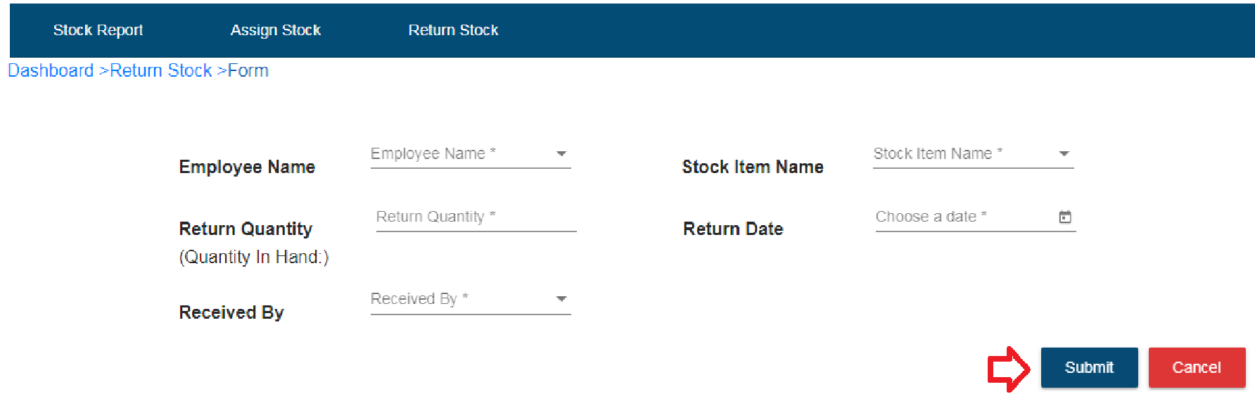

Fig. Return stock

* After click on submit button record will display in return stock table.
* Select date from and date to.
* Click on the searchbutton.
* After click on search button, particular record will be displayed.

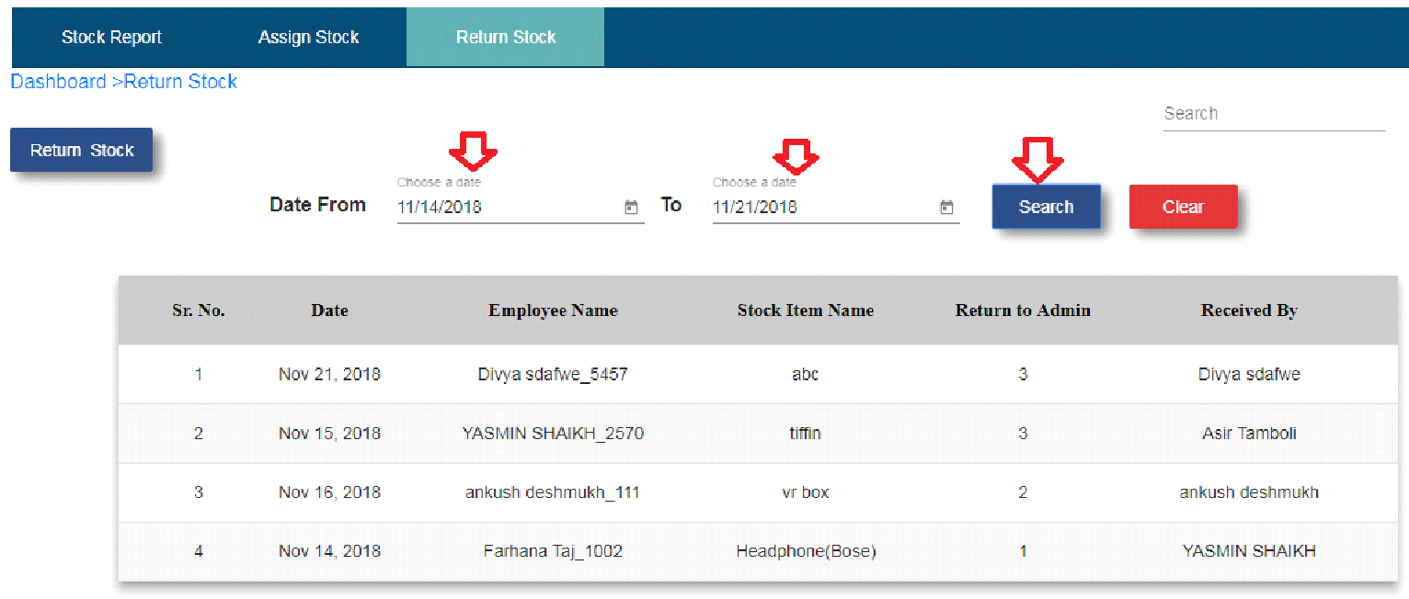

Fig. Return Stock Search Button

* **Stock Report Table**
* When user add stock, then stock count show in new purchase column.
* Total stock show total stock quantity.
* Total issue column show how much stock user taken from total stock.
* Total return column show how much stock user returned from total issue stock.
* Given to customer column show how much stock user given to customer from total issue.
* Available stock column show how much stock is available from total stock minus given to customer.

**9. Payroll**

* Click on payroll module.

**1. Advance management**

* Click on advance management sub module.
* Click on add button.
* Select team lead name.
* Select employee name.

Note: Employee should be team member of any one of the team lead.

* Enter process.
* Salary type will be auto generated.
* Enter advance amount.
* Select issued by.
* Select date.
* Enter remark.
* Click on create button.

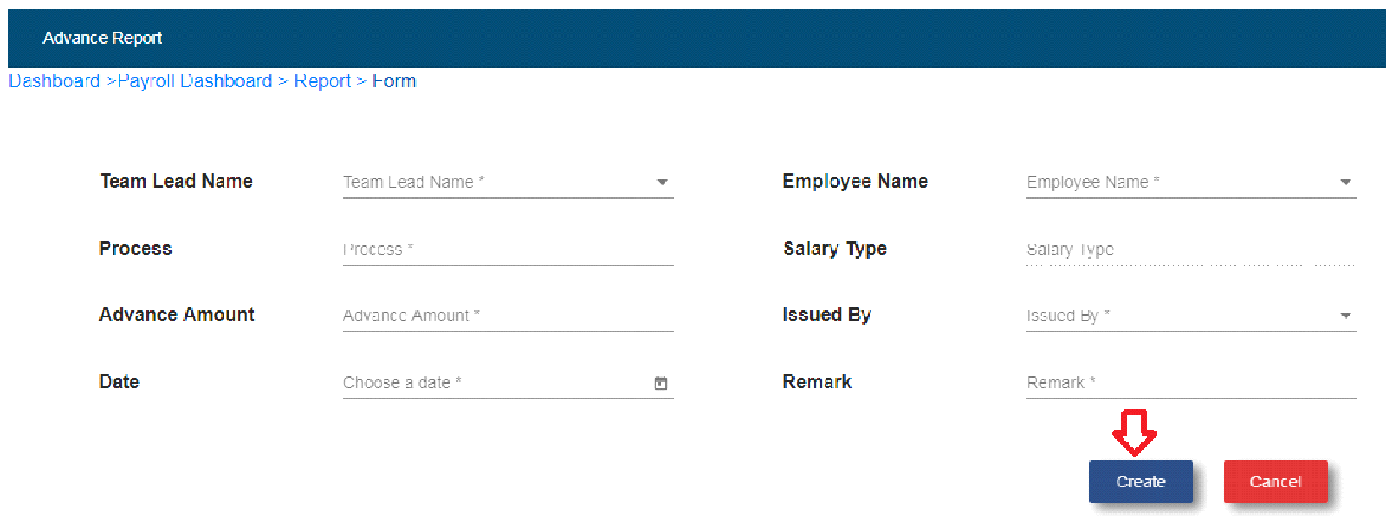

Fig. Advance Report Form

* After click on create button, record will be displayed in the advance report table.
* Click on edit operation.

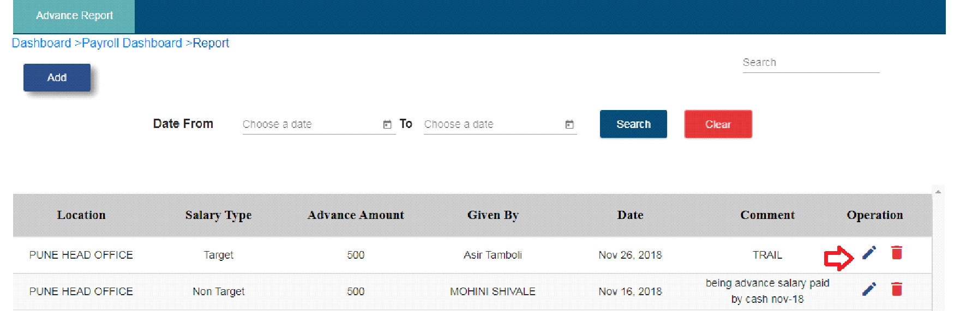

Fig. Advance Report Edit Operation

* If user wants to edit details then edit it and click on update button.

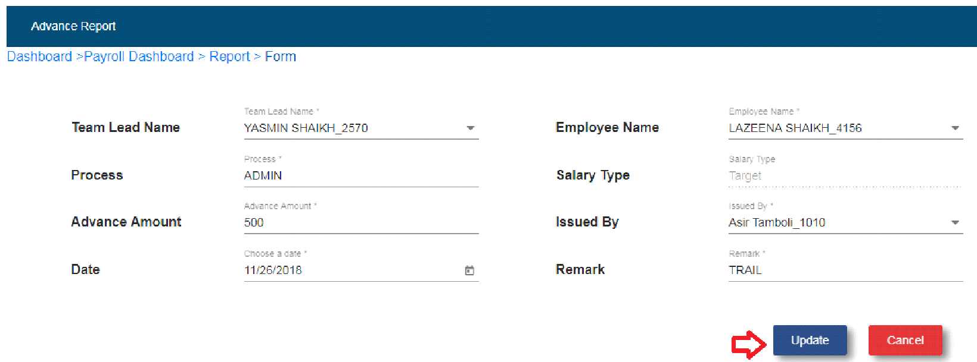

Fig. Update Advance Report form

* Click on delete operation.
* If user wants to delete advance record then click on delete operation.
* Select date from and date to.
* Click on search button.
* After click on search button user is able to search the records.

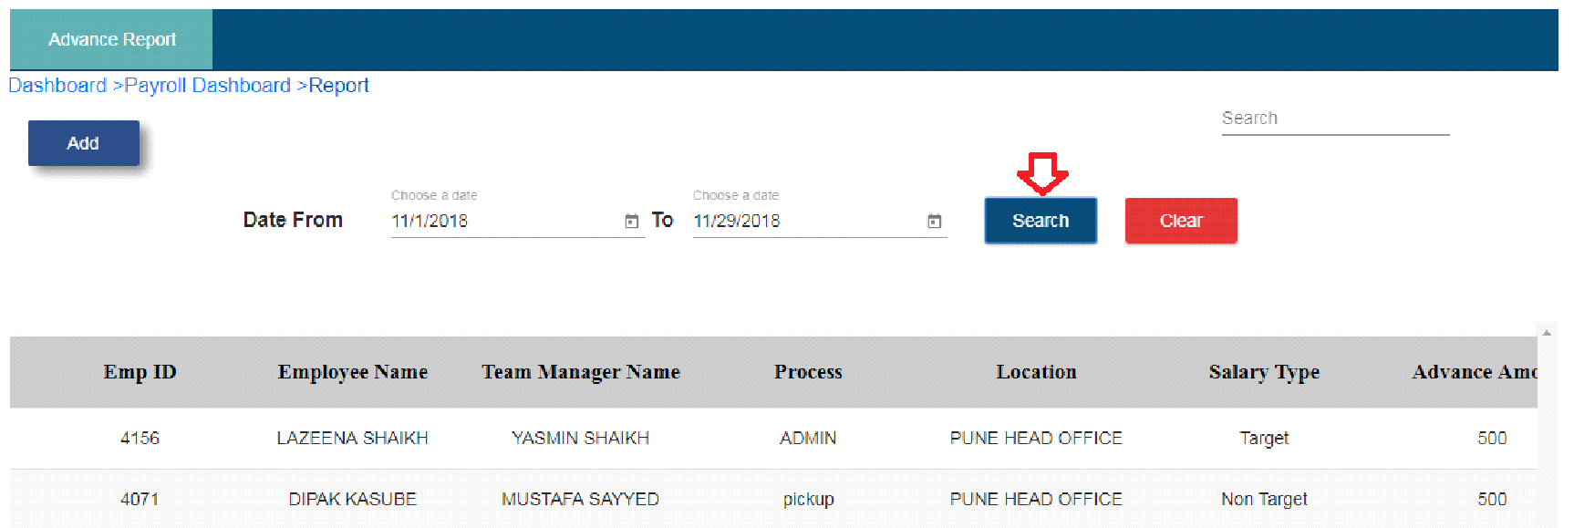

Fig. Advance Report Search Records

**2. Prime**

* Click on prime sub module.

**a. Prime Report**

Note: 1. Name column shows team lead name in bold and TME name.

2. TME should be a member of team lead and TME should be assigned to any one of the team lead.

3. ICICI bank declined code – MAR – Status – Multiapproved

4. SCB bank declined code – SR00 – Status – Multiapproved

5. Declined code means promo code – It will come from MIS Import master Table

6. Yes bank column show only DIP and point count.

7. RBL bank is not present in prime report.

8. Final DIP count present only for ICICI bank.

* DIP count comes from MIS import master table to that particular record. This count is count of team member DIP count.
* Points will calculate as per card master, which bank will have how much card points according to that.
* Approved count comes from MIS import master table.
* Declined count comes from MIS import master table.
* Total = Approved +Declined
* Percent(%) – Approved/Total

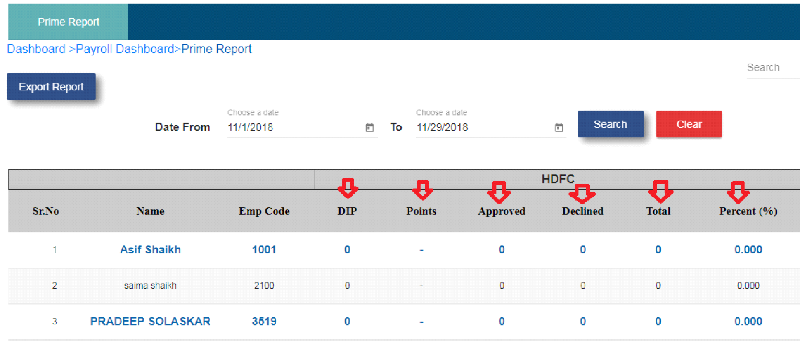

Fig. Prime Report

* **Total**

1. DIP – Total DIP count

2. Points – Total points count

3. Approved – total count of approved

4. Declined – Total count of declined

5. Total – Approved total + Declined total

6. Percent – Approved/ total *100

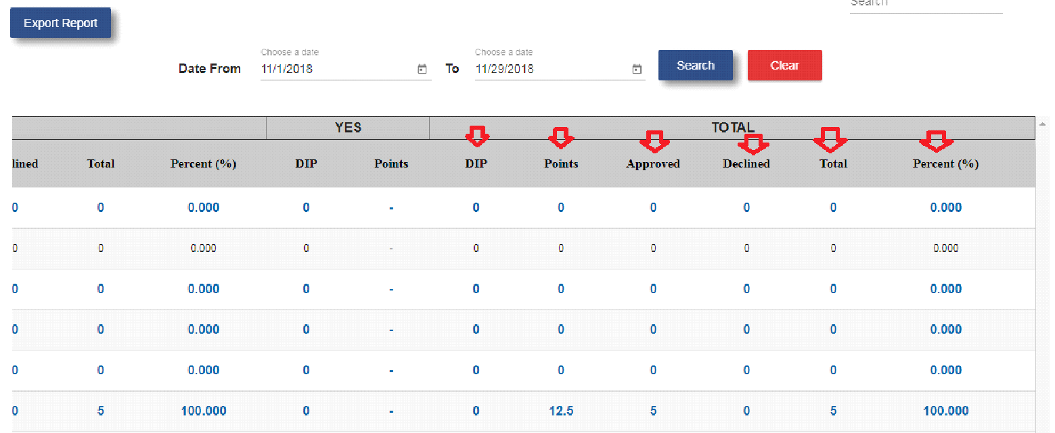

Fig. Prime Report Total

* **Grand Total**

1. Grand total calculate as per column.

2. In grand total only team lead count will be calculated which is display bold in the table.

3. Grand total is addition of all team lead records.

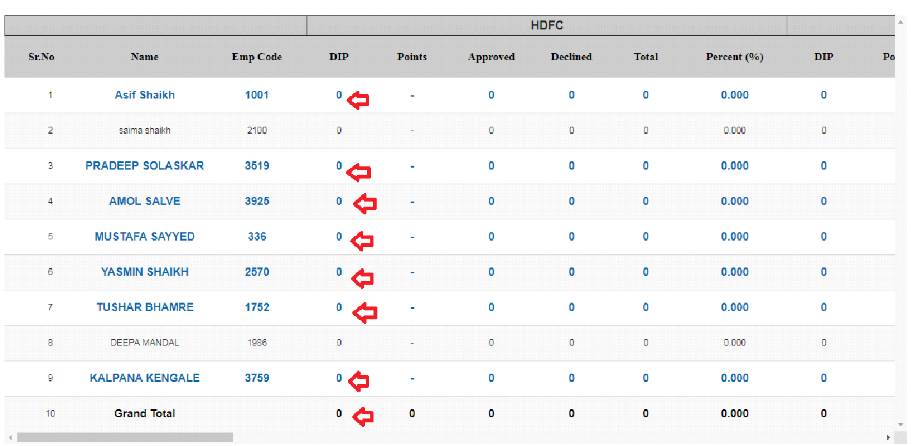

Fig. Prime Report Grand Total

* Date from and date to display one month record.
* User will able to search date as per month.
* User will able to export prime report in excel sheet format.

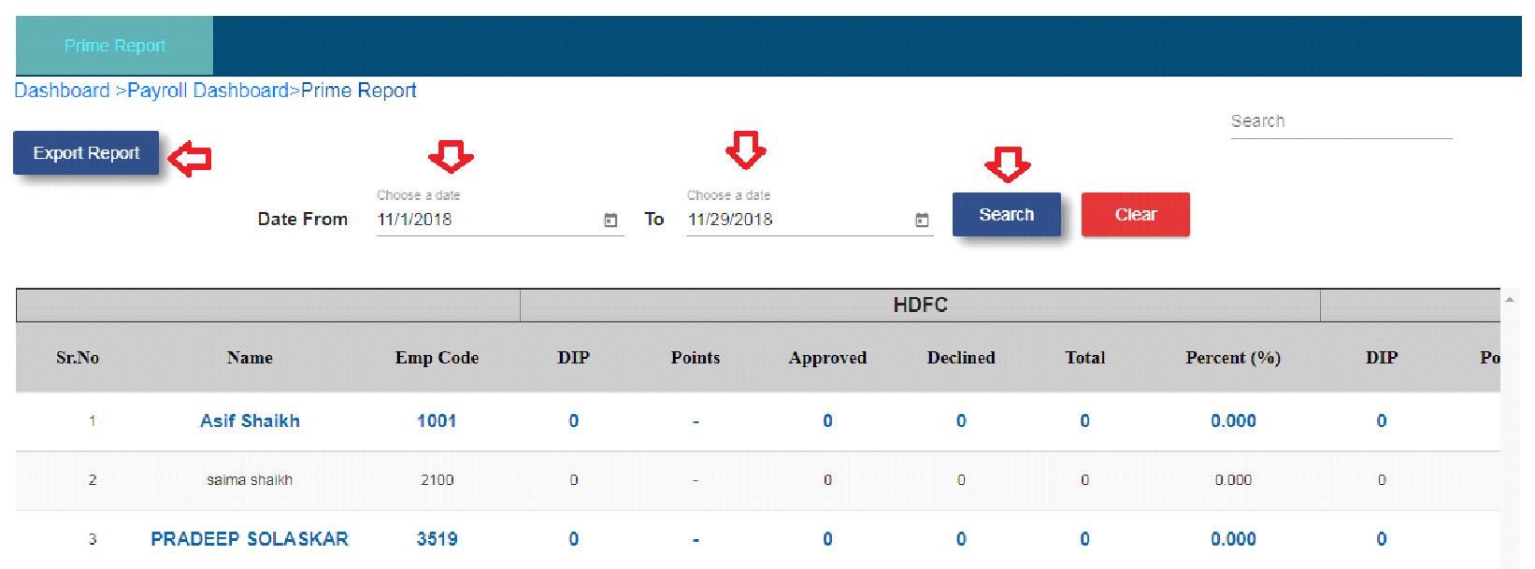

Fig. Prime Report Search and Export

**2. Payroll Report**

* Click on payroll report sub module.

**a. Payroll Master**

* Click on payroll master tab.
* Date field show only current month of the records. If user wants to search for another month record then choose another month.
* Date field show only one month of records.

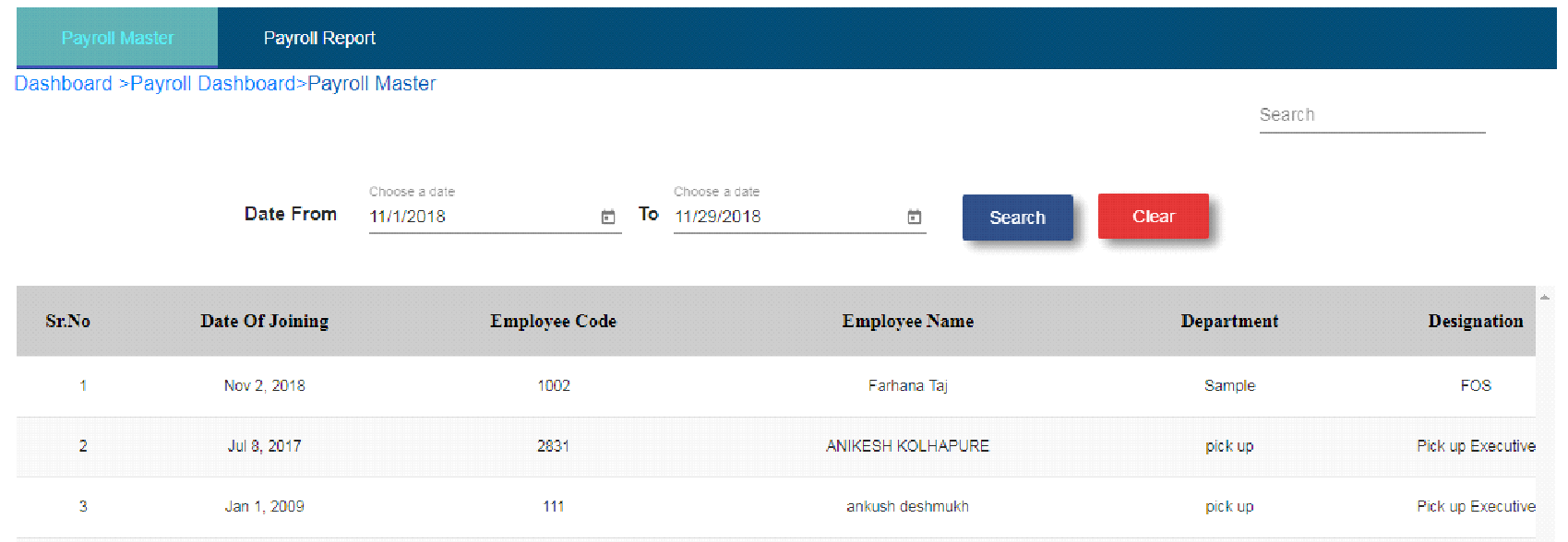

Fig. Payroll Master Search

Note: 1. In payroll report all employee record will display.

2. If any user completed target then incentive will apply to that user.

3. So, first super admin need to approve incentive.

|  |  |
| --- | --- |
| Heading | Comment |
| DOJ | DOJ will come from Employee master |
| EMPLOYEE CODE | EMPLOYEE CODE |
| EMP NAME | Source: Employee master |
| DEPT | Source: Employee master |
| DESIGNATION | Source: Employee master |
|  |  |

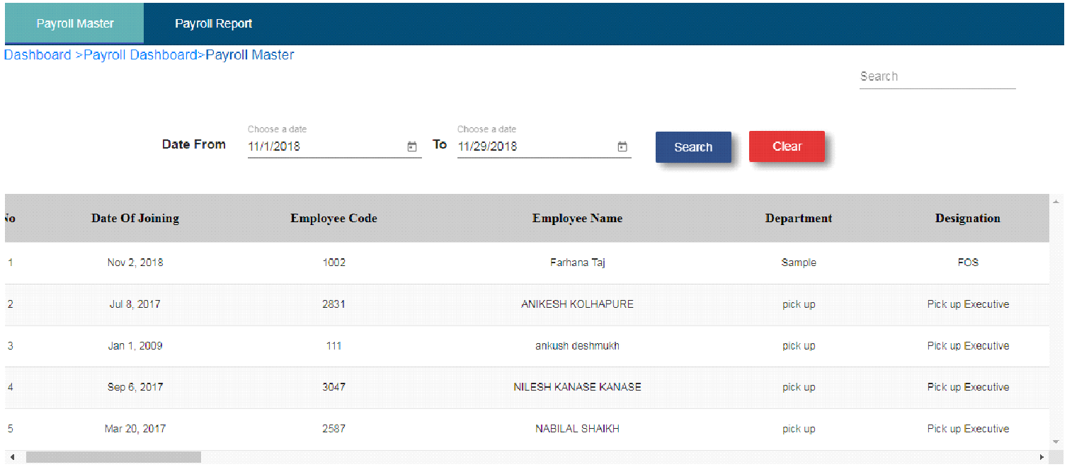

Fig. Payroll Master Table1

|  |  |
| --- | --- |
| Heading | Comment |
| TEAM MANAGER | Source: Employee master |
| SALARY TYPE | Fixed, Target, Fixed + Incentives (SOURCE: EMP MASTER) |
| SALARY ON TARGET | DIP * amount |
| FIX SALARY (A) | Source: Employee master |
| SALARY AS PER TARGET | Source: Employee master |
|  |  |
| PROFESSIONAL TAX | SALARY IS > 5000 AND < 10000 THEN PT SHOULD BE 175, AND SALARY IS > 10000 THEN PTY SHOULD BE 200 |

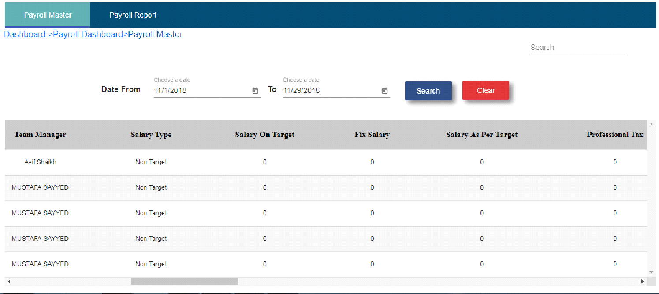

Fig. Payroll Master Table2

|  |  |
| --- | --- |
| Heading | Comment |
| Salary after professional tax | (Fix salary - Professional Tax) |
| Basic Salary | 40% of Gross/Fix salary |
| Per day Salary | (salary after PT/30) |
| CARDS DIP | Source: Prime report |
| STB | Source: Prime report |
| APPROVED | Source: Prime report |
| DECLINED | Source: Prime report |
| TOTAL | Source: Prime report |

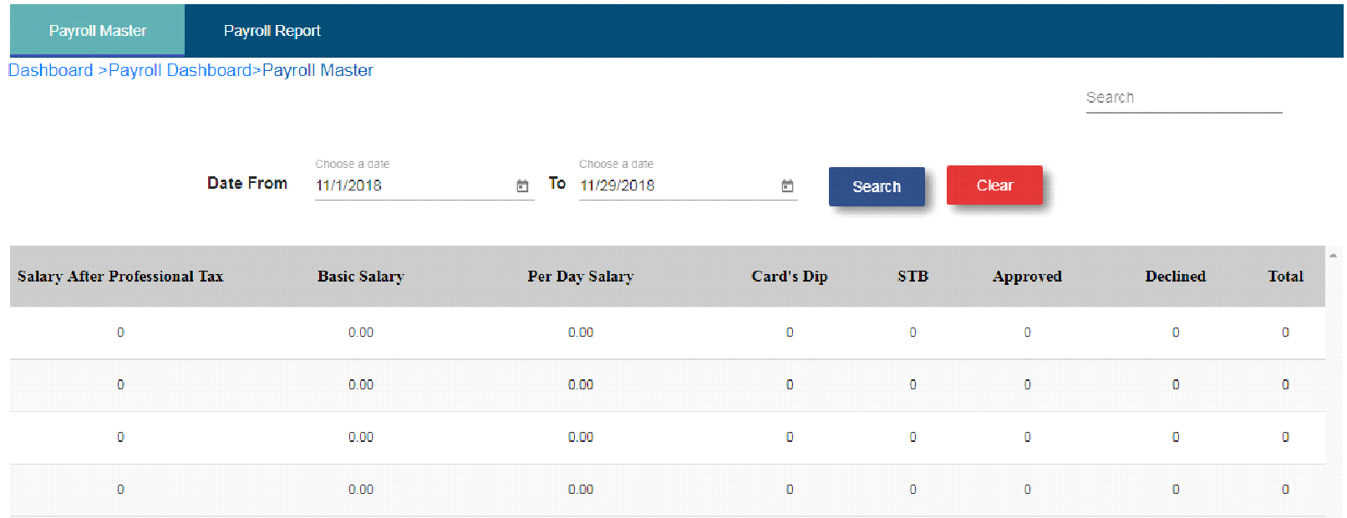

Fig. Payroll Master Table3

|  |  |
| --- | --- |
| Heading | Comment |
| PERCENTAGE | Source: Prime report |
| TOTAL POINTS | Source: Prime report |
| **INCENTIVE (B)** | **(total points * amount (source: points/value master))** |
| **Total Salary** | **(A+B+C) Fix salary + Incentives** |
| **PRESENT** | **Source: Attendance module** |
| **ABSENT** | **Source: Attendance module** |
| **LATE MARKS** | **Source: Attendance module** |
| **LATE MARKS-ABS** | **(Late marks / 3)** |

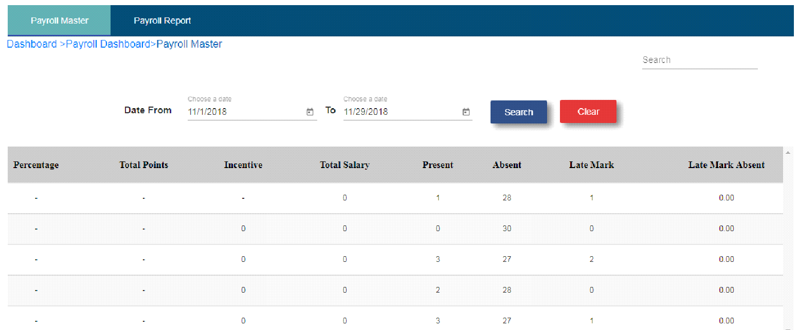

Fig. Payroll Master Table 4

|  |  |  |
| --- | --- | --- |
| Heading | Comment | |
| LATE MARKS DED (b) | (late marks ABS * per day salary) | |
| ADVANCES (f) | Source: Advance module | |
| P.F AMOUNT (c ) | 12% of basic salary | |
| GIFT DEDUCTIONS (d) | Stock module | |
| ABSENT CUTTING (e) | (absent-UA Absent) * per day salary) | |
| **DEDUCTION** | **(a+ b+ c+ d+ e+ f) (UA ABS deduction + late marks deduction + advances + PF amount + Gift deduction + Absent cutting** | |
| NET SAL | (total salary - deductions) | |
|  | | |
|  | | |
|  | | |
| Fig. Payroll Master Table5 | | |
| * Salary column shows - (net salary - incentives) * Department column shows address. * Click on edit operation. | | |
| Fig. Payroll Master Edit Operation | |
| * After click on edit operation, fill all the enable and mandatory fields. * Click on create button. * After click on create button, record will display in payroll report. | |
| Fig. Payroll Master Update Form | |
|  | |
| **b. Payroll Report**   * Click on payroll report tab. * Choose month and year. * Click on the search button. * User will able to search data according to month and year. * By default month will show current month and year show current year. * User is also able to export report in excel sheet format.     Fig. Payroll Report   * When user click on adjustment operation user will able to enter adjustment value in that textbox. * After that adjustment value get added into actual salary in employee.     Fig. Adjustment Operation | |
|  | |
|  | |
|  | |
|  | |